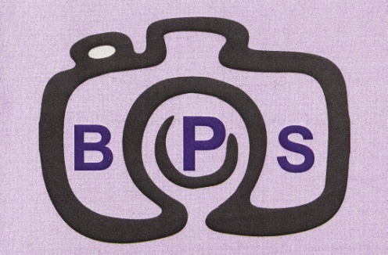

THE
BROMSGROVE PHOTOGRAPHIC SOCIETY

70th ANNIVERSARY YEAR
1950 – 2020

LOOKING BACK OVER THE HISTORY

From the Archives
Volume 1
The early years 1950 to 1980

© The Bromsgrove Photographic Society
Bromsgrove Photographic Society – 1950

The information contained in this document has been compiled from notes preserved by the Society’s Secretaries over the years since its formation. As the current Secretary and custodian of the Society archives, I have arranged the highlights of the first decade to be converted for the digital age for use in the celebration of the Society’s 70th Anniversary. If they prove of interest to the membership, I will continue the project as far as possible.

We are indebted to J. Hadley who was an Archivist and compiled copious notes from the original records up to the 40th Year’s Anniversary in 1990. There were no minutes of monthly meetings between 1966 and 1969 only AGM minutes.
David Ward A.R.P.S. Secretary 2020

The Society was originally formed from a nucleus of members, attending a Photographic course at Bromsgrove Technical School.

The inaugural meeting was held at the Red Lion Public House, High Street, Bromsgrove, on March 22nd 1950.

The meeting was convened by Mr. G.V. Billson who was to be known as the “Founder”.

A list of the original members can be found on the next page.

All meetings for the first three months were held at the Red Lion until the Society was fortunate in obtaining the tenancy of rooms at 152 Worcester Road.

The main room was a former Store Building and required much hard work by Members by way of decorating and altering before it was fit for use.

The main Clubroom was officially opened on 5th June 1950 by Mr. Donald Allen F.R.P.S. F.R.S.A. and was attended by 56 members and friends.

Dr. A. Shepherd MB. ChB. DPM, President of the Society at that time, opened the meeting with a vote of thanks to the Society members for all the work they had put in. In particular Mr. G.V. Billson without whom it was felt the Society could not have progressed as far as it had in such a short space of time.

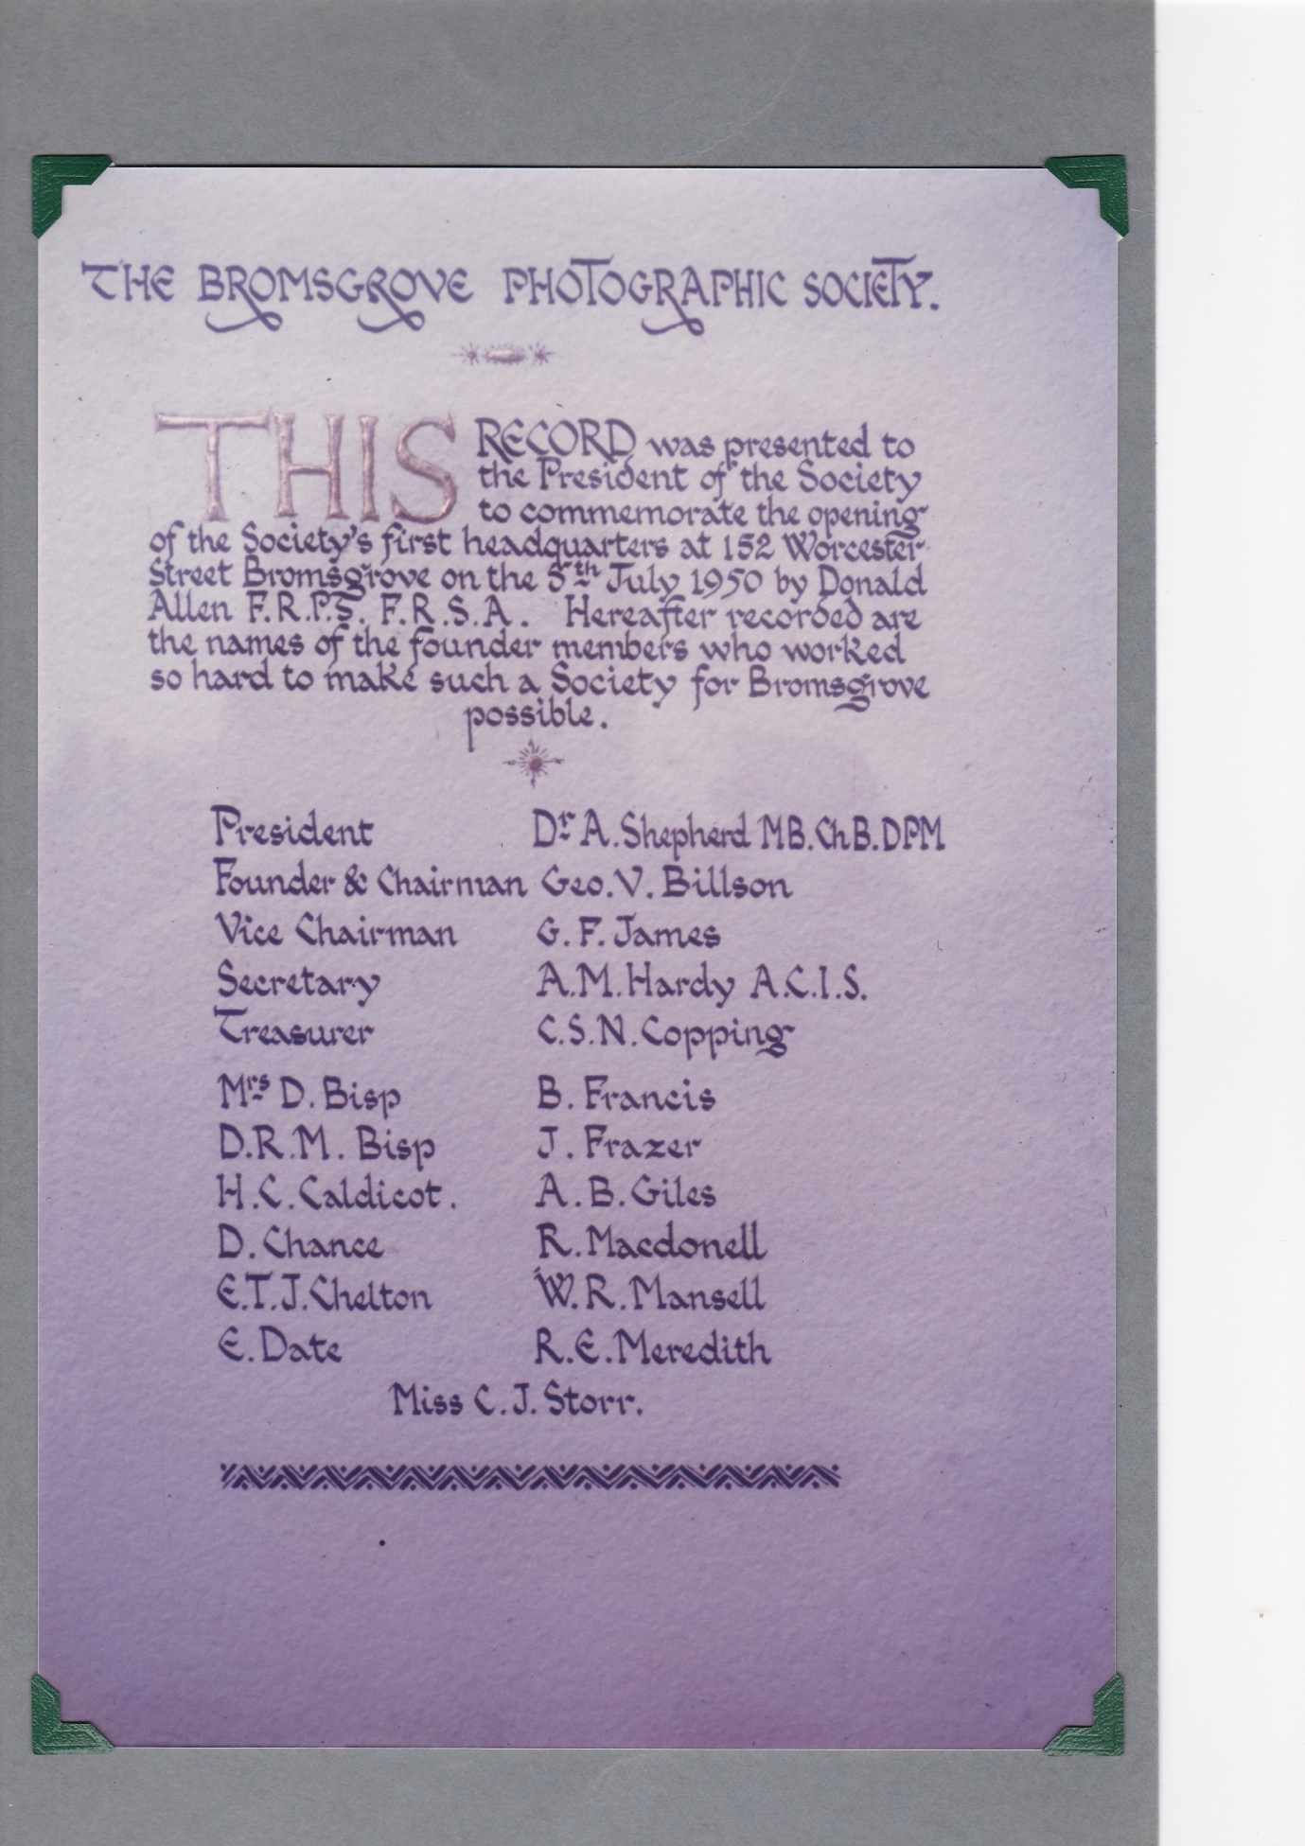
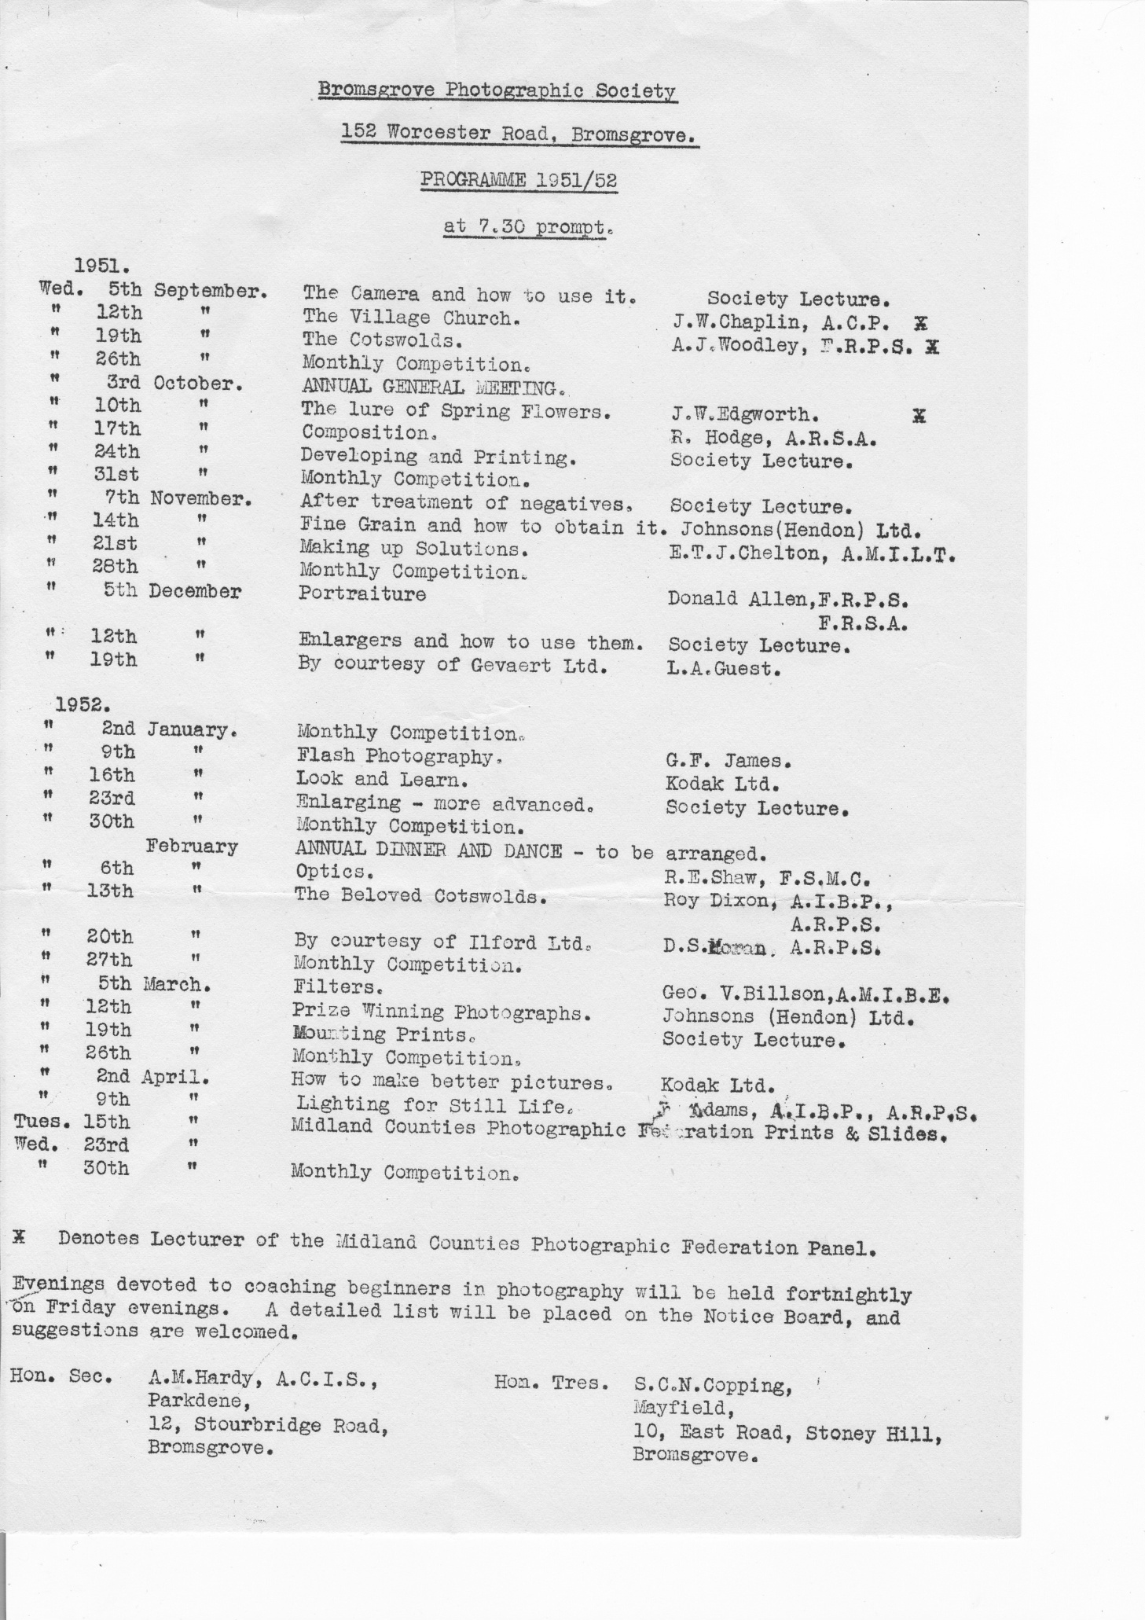
The Early days.
The Archives
The only permanent record of the Society’s activities since it was formed has been in the form of minutes from Committee meetings. These are rather sketchy in detail but as archivist I have tried to sift out the most important and interesting passages and present them here for the enjoyment of members both present and future.
J. Hadley
-oOo-
The following are extracts from J. Hadley’s work. The archives also contain old exhibition posters, printed programmes, photographs and newspaper clippings.
1950
22nd March 1950
The inaugural meeting at which the name Bromsgrove Photographic Society was decided upon. This name was chosen in preference to other suggestions of, Bromsgrove Camera Club, Bromsgrove & District Photographic Society.
The first election of officers was also held and sub-committees to deal with both finance and rules were formed.
5th April 1950
The annual subscriptions for members were decided upon as follows;
Full Members £1-1-0
Junior Members £0-10-6
Member and Wife £1-11-6
An entrance fee 0f 2/6d including a book of rules would be charged for new members.
Mr. Giles, Landlord of the Red Lion Public House was thanked for use of the room for Society meetings. It was however unanimously decided by members to try and obtain unlicensed premises for the future.
19th April 1950
The meeting was informed that the Society had been affiliated to the Royal Photographic Society of Great Britain; The Midland Counties Photographic Federation and the Photographic Alliance.
17th May 1950
Members decided unanimously that the premises adjoining Mr. Meredith’s home at 152 Worcester Road, Bromsgrove, were by far the best and most suitable for Society use.
Upon learning the Terms for these premises, which included a very reasonable 5/- per week rental, it was agreed that 152, Worcester Road would indeed become the Society’s new home.
31st May 1950
The first monthly competition was held and judged by Mr. Shepherd, the then President of the Society.
13th June 1950
The first full Committee meeting at 152, Worcester Road.
5th July 1950
The official opening of the new headquarters by Mr. Donald Allen F.R.P.S.
2nd August 1950
Work on the darkroom was now complete and it would be open for use by members at all times.
It was decided to insure the Clubroom and its contents for a sum of £200-0-0.
4th September 1950
First Annual General Meeting of the Society attended by 19 members.
(Amongst the officers elected at this meeting was Mr. A.B. Giles (Meetings Steward) and who is the only founder member still actually connected with the Society in 1971).
1st November 1950
Members and guests from Stourbridge Photographic Society were given a lecture by H.H. Bleads A.R.P.S. on his methods. Although the lecture was enjoyed by all present, the Committee were rather shocked and upset to find that Mr. Bleads had charged £2-0-0 as travelling expenses by car from Birmingham.

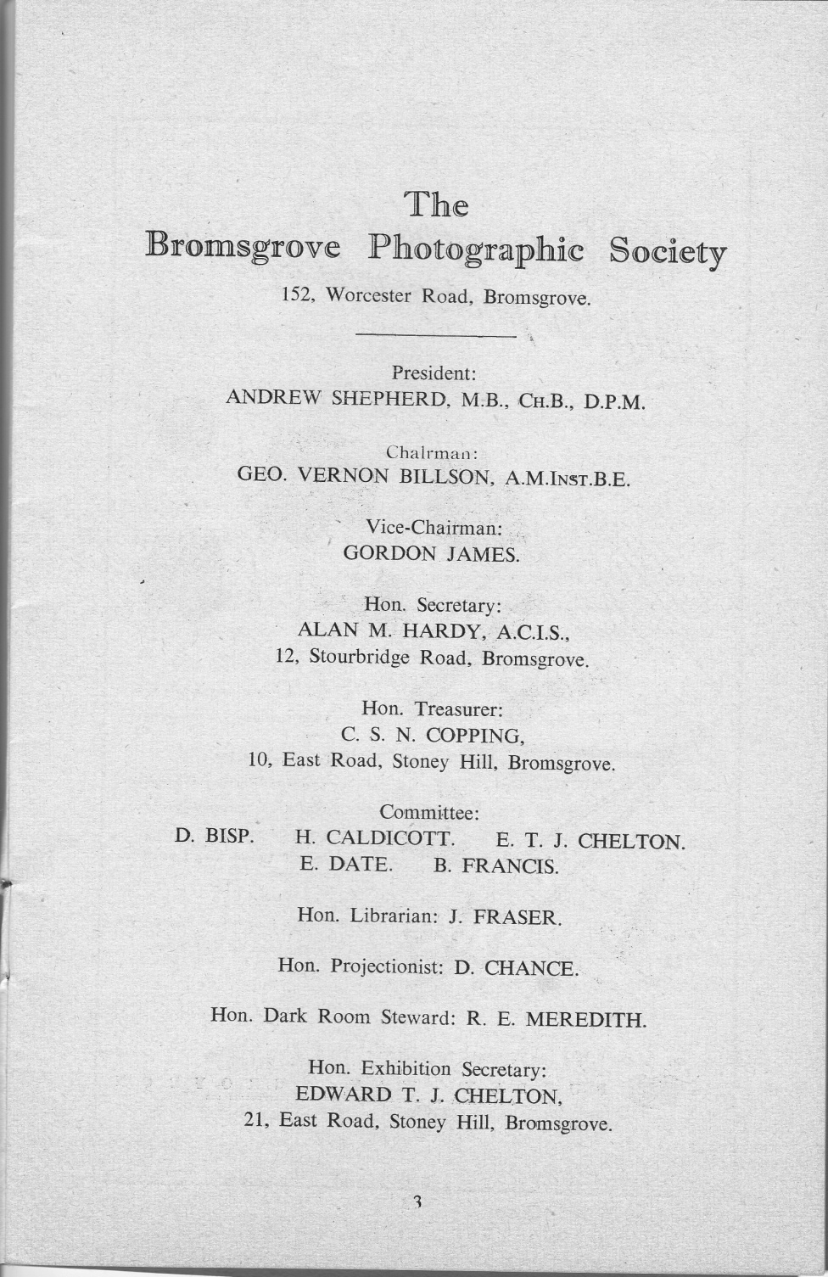
1951

11th May 1951
First Annual Exhibition.
This was held at Bromsgrove Technical School and was judged by Mr. Donald Allen F.R.P.S. Out of 225 entries from all over the Midlands, 131 were accepted and hung in three separate classes. Open, Technical & Scientific and Members.
On the following page there is a scan from the original entry form.

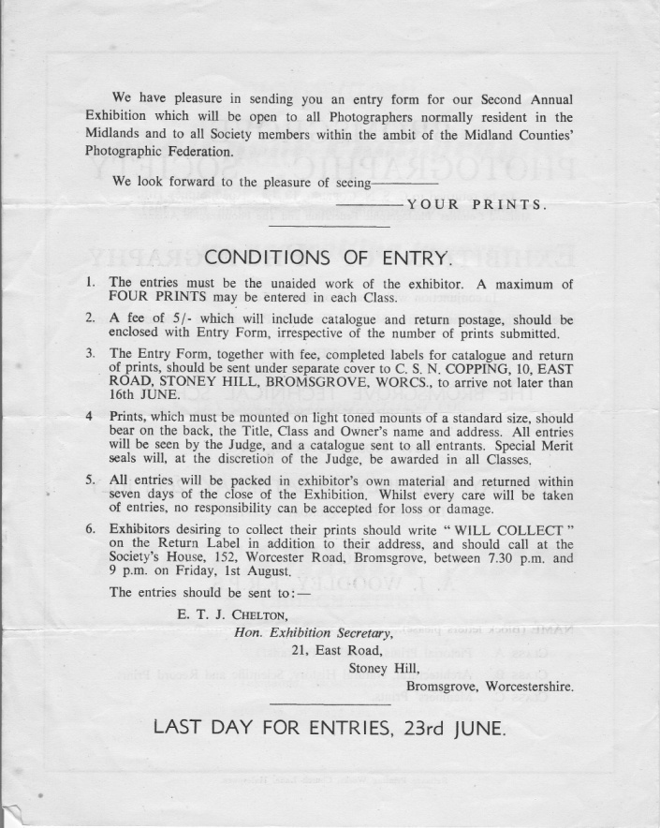
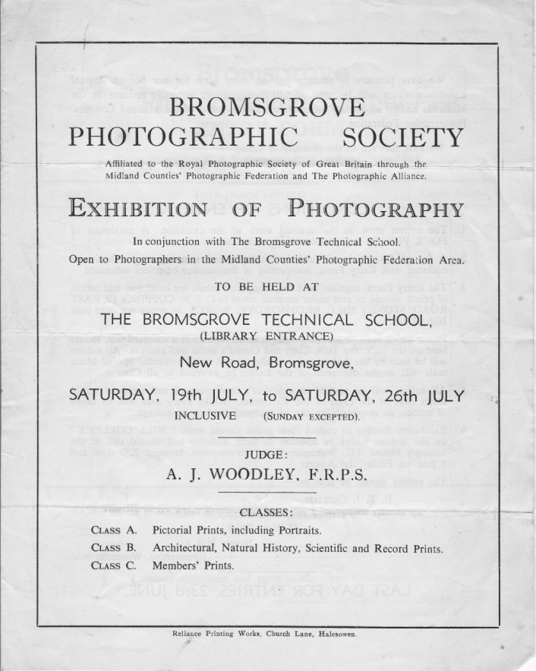

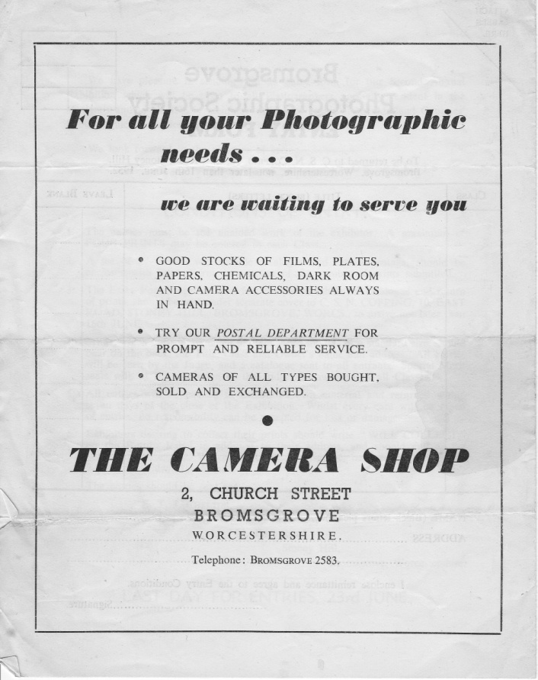
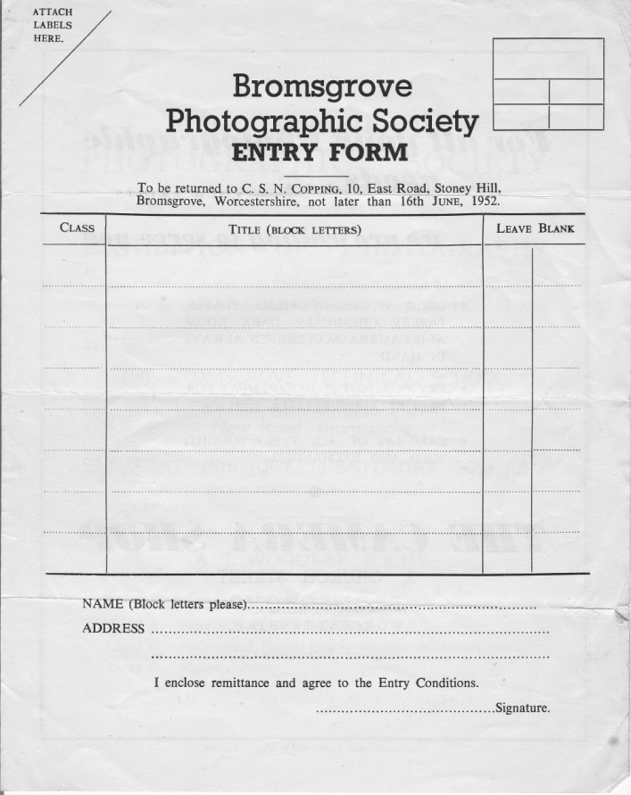

Above is a scan of the original 1951 Exhibition Entry Form.
The archive also has a copy of the original 1951 Exhibition Programme containing a list of all the exhibitors.
There were three classes:
Class ‘A’ (Open Pictorial)
Class ‘B’ (Open Technical and Record Class)
Class ‘C’ (Members Class)
30th July 1951
Mr. G.V. Billson kindly offered to donate a cup to be known as the “Founders Cup” which would be awarded each year to the member submitting the best of 4 prints.
3rd October 1951
Annual General Meeting
It was reported that membership had risen from 30 at the last A.G.M. to a healthy 62.
The Treasurer informed members that the Society’s finances were well into the “black” and particularly noted a profit of over £15-0-0 on the first Exhibition.
1952
19th – 26th July 1952
2nd Annual Exhibition
From the 900 entry forms sent out, 253 entries were received from over 50 workers. The Exhibition was judged by Mr. A.J. Woodley F.R.P.S.
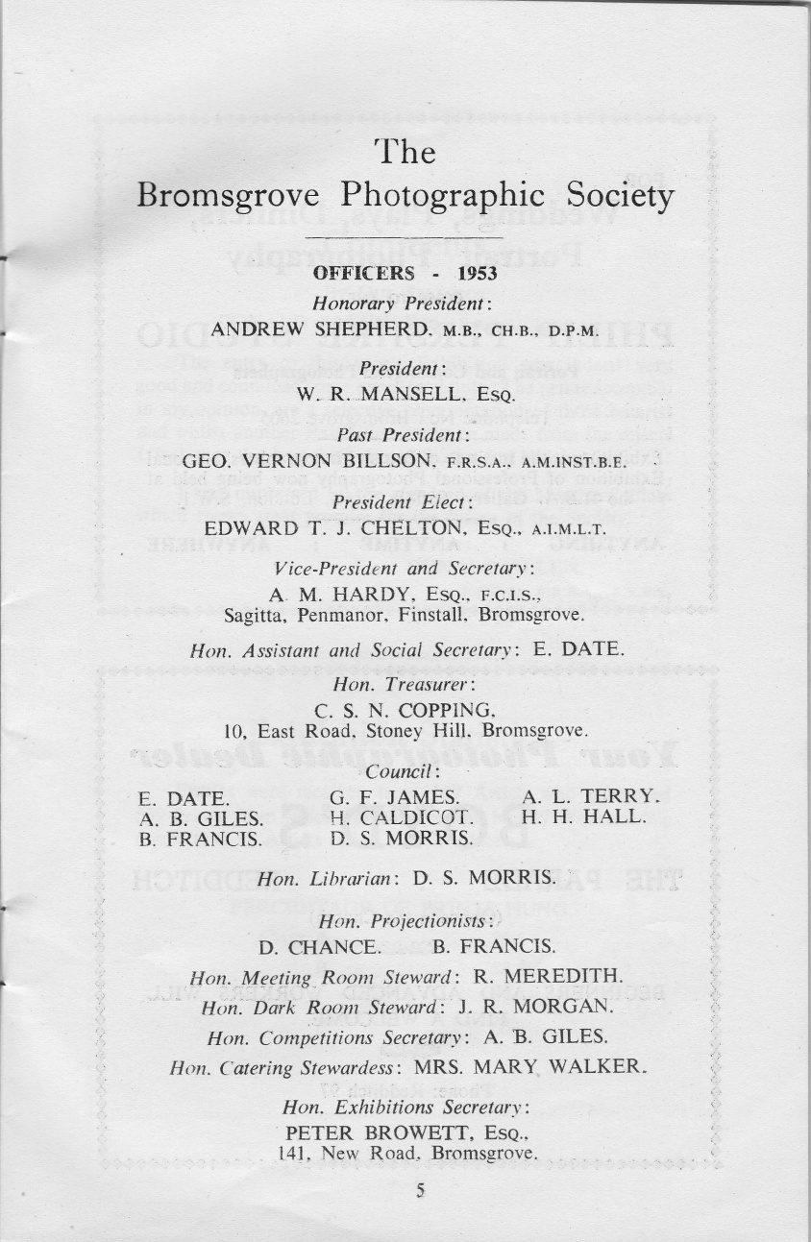
1953

26th August 1953
Annual General Meeting
The Treasurer report showed a very healthy £80-4-8d balance at the bank due mainly to the success of the 3rd Annual Exhibition held in May which had shown a profit of over £46-0-0.
27th October 1953
Due to a suggestion by Mr. Harrison, it was decided to add to the monthly competitions a new Technical & Record section which it was hoped would encourage photographers who were interested in subjects other than Pictorial. Mr. Harrison offered to donate a cup to be used for this section.
1954/55
6th April 1954
The Secretary was asked to write to the M.E.B. (Midlands Electricity Board) asking that the Society be put on a concession rate of 1d per unit for the electricity supply. The reason to be given for this request would be that the Society was a social and cultural organisation, run on a strictly non-profit making basis.

7th December 1954
HONOURS BOARD
After much discussion on this subject, Mr. Copping agreed to bring some ideas for the production of this Board to the next meeting.
(Little did the Committee at that time realise that ideas and suggestions regarding the Honours Board would be brought up at many meetings for the next 17 years).

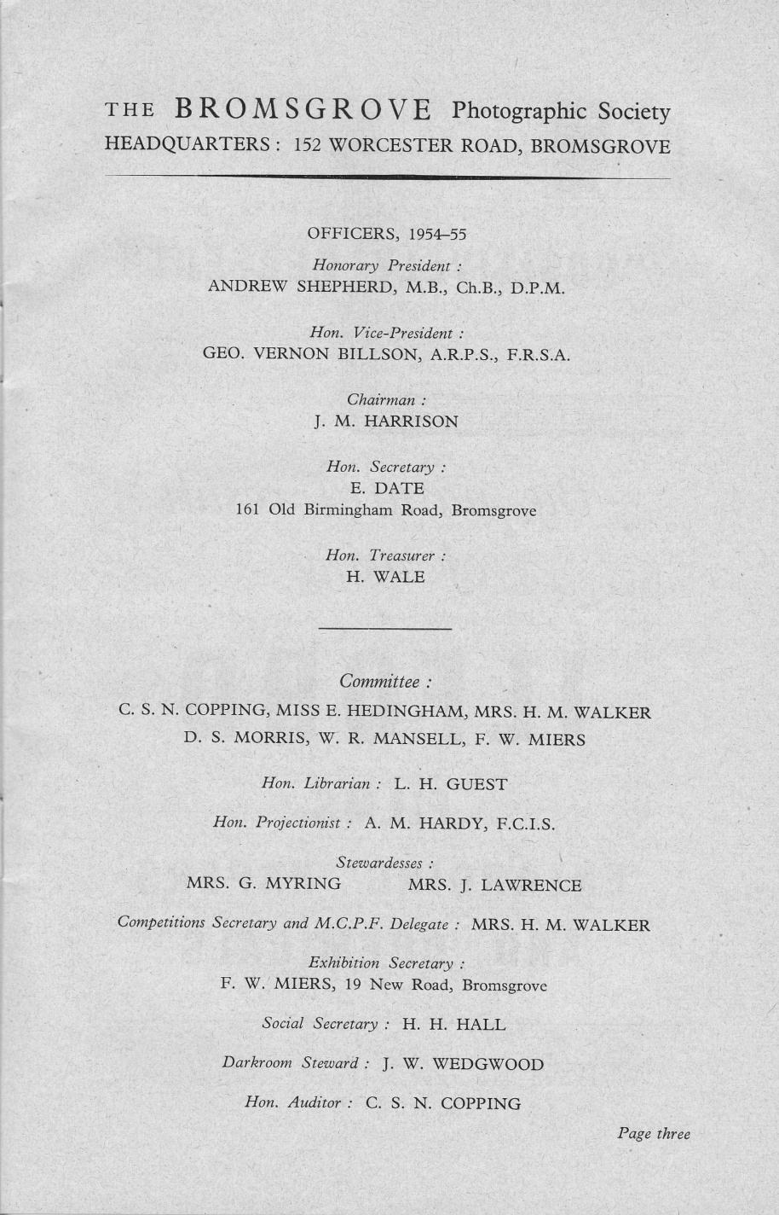

25th January 1955
The question of Colour Photography was discussed at some length. For the first time, the possibility of having a colour section in monthly competitions was considered.
Honours Board – this matter was deferred to the next meeting.

26th April 1955
HONOURS BOARD - The meeting felt that it was a good idea to have an Honours Board and Mr. Mansell agreed to provide a quotation at the next meeting.
Annual Exhibition - Although the Exhibition was of a generally high standard, for the first time on record, it was a financial failure. It made a loss of approximately £3-10-0. The question was raised as to whether an exhibition would be held the following year.
1st June 1955
HONOURS BOARD - Mr. Mansell said he would attend to this after the redecoration of the clubroom.
Subscriptions – The Treasurer reported that although on paper the Society had more than 50 members, only 17 had paid their subscriptions for the year.
12th October 1955
Annual General Meeting
The Chairman Mr. J.M. Harrison reported on a satisfactory season with a marked improvement being shown in weekly attendances towards the end of the season.
He also reported that although competitions had been well supported generally, the Technical & Record section was to be suspended through lack of support.
1956/57
6th June 1956
It was decided that as no suitable venue could be found, there would after all be no Annual Exhibition this year.
Attention was brought to the fact that several members had voiced dissatisfaction with the performance and record of the present Committee. They felt that little interest was being shown in the activities of the Society and that a new committee should be formed as soon as possible.
Mr. Harrison and Mr. Miers who brought this matter to the attention of the Committee felt tat the complaint was entirely justified and they personally felt that the Society was rapidly lapsing into a state of decay.
It was decided after a good deal of discussion that any alterations to be made regarding this complaint would best be left till the next A.G.M. which would be held in September.

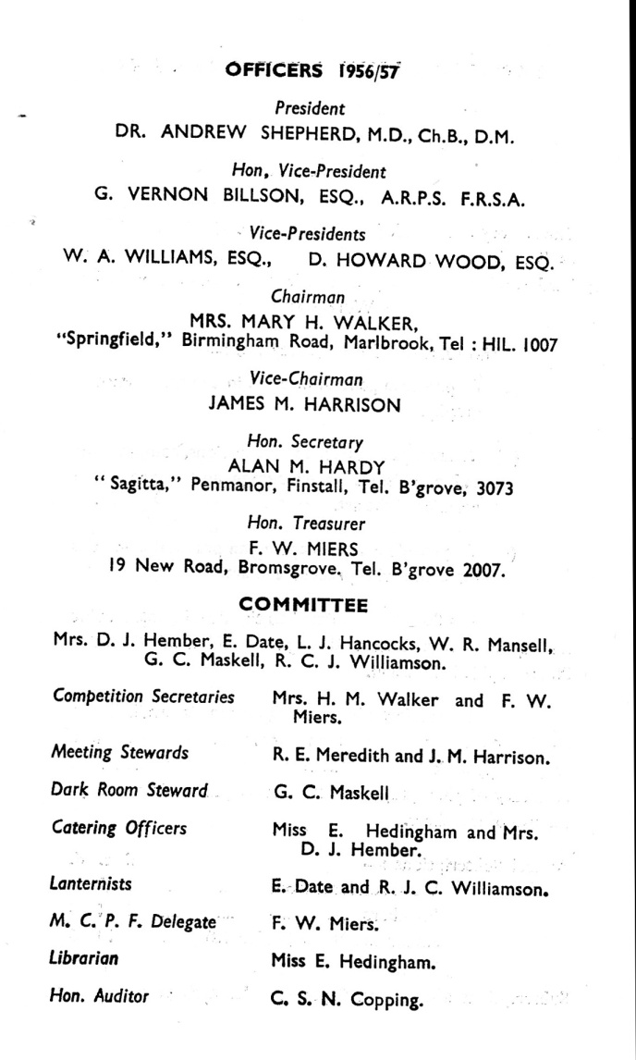

18th September 1956
A new Committee with a number of changes was elected to the satisfaction of the members. The Society Rules were also amended to meet the approval of the members at the time.
The Chairman reported that attendances at weekly meeting had been fairly good except on the occasions we had visiting lecturers when audiences of 18-20 were not considered satisfactory.
Several members had been successful on “Open” competitions throughout the year, the most notable of which being Mr. F.W. Miers who had 2 exhibits at the Royal Photographic Society.
10th December 1956
Mr. F.W. Miers commented that the advanced workers seemed to be transferring their efforts more and more to colour photography. He hoped that this would not lead to the complete exclusion of monochrome work.

1957/58
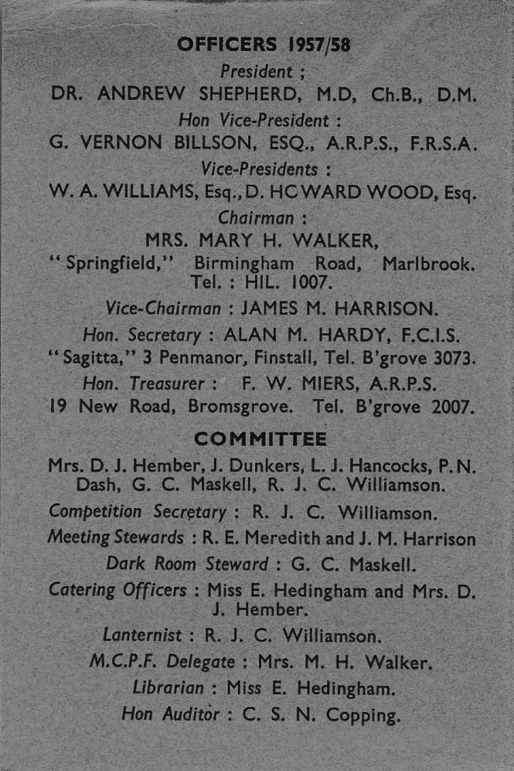

16th September 1957
It was announced that wing to the state of the Society’s finances, a temporary overdraft had been arranged at the Bank. It was suggested that weekly raffles be arranged to try and improve the financial position.
Mr. Hancox suggested the formation of a Cine Section as this type of photography was becoming increasingly popular. After much discussion it was agreed that this would be a desirable addition to the Society and that interested parties should bring their proposals forward at the next meeting.
6th November 1957
Proposed Cine Section – Mr. Dash as spokesman for the interested members gave details of a meeting held on the 29th October in the Clubroom and asked for approval of suggestions made.
It was proposed that the annual subscription should be one and a half guineas; £1.1.0. being paid into the Treasury of the parent section and the Cine section retaining 10/6d.
There was prolonged discussion on all aspects of the new venture and it was finally proposed by Mr. Dash that as the Committee agreed to accept the proposal that a Cine section should be formed in accordance with the suggested rules, an Extraordinary Annual Meeting should be called for ratification of the proposal.
27th November 1957
Extraordinary Annual Meeting
The Chairman explained the reason for calling the meeting and read the proposed rules regarding the formation of a Cine Section.
The proposal that the Cine Section be accepted as part of Bromsgrove Photographic Society was put to the meeting.
The Chairman said that now we had accepted the new section she, as Chairman, wished the new venture the best of luck and hoped they would get as many members as they wished and that they would have a lot of happiness in becoming part of our Society.
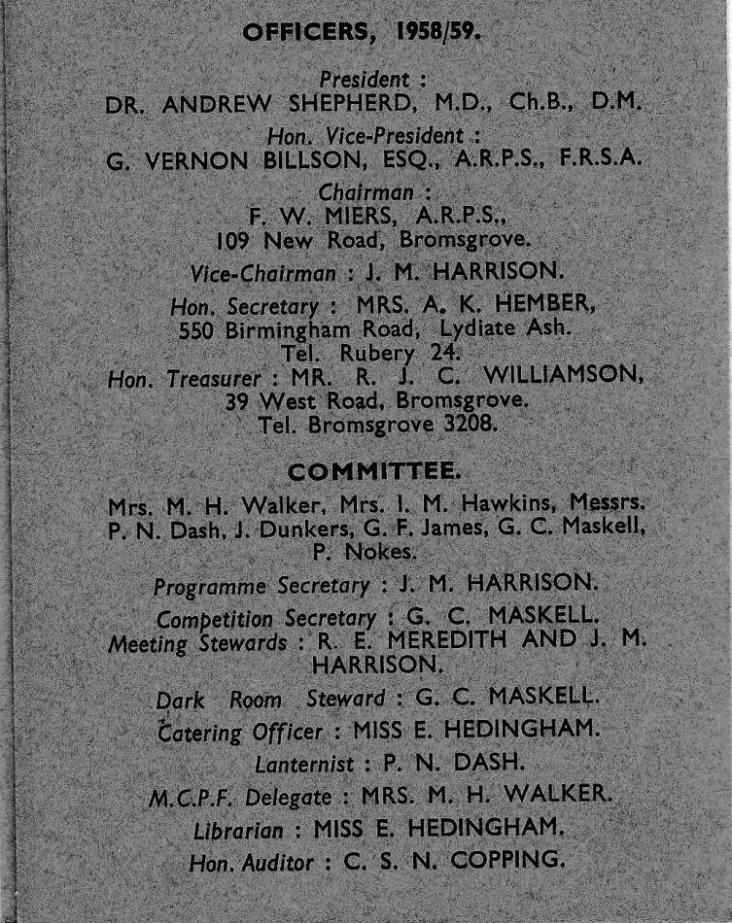
1958/59

24th November 1958 (A.G.M.)
6th May 1959 (E.G.M)
The majority of the time at these two meetings was taken up with the question of finance.
At the A.G.M. the Treasurer reported that even with the addition of the Cine Section which brought in extra revenue, the finances of the Society seemed to balance on the outcome of the Xmas raffle which in turn relied on the generosity of a few members. Mr. Harrison in particular was thanked for arranging these raffles.
Cine Section
Certain members of the Cine Section felt that they were paying too high a percentage of their subscription to the parent society. It was however pointed out that the Cine Section had the use of a fully equipped Clubroom and that heating, lighting and rent bills all had to be paid somehow.
Members were informed that to add to the Society’s already considerable financial problems, the landlord proposed to increase the weekly rental for the Clubroom from 5/- to a more realistic 10/-.
The final outcome of these somewhat hectic meetings was that members agreed to an increase in the Annual Subscriptions from £1-1-0 to £1-11-6 with a an extra levy of 10/6d for members wishing to join the Cine Section.
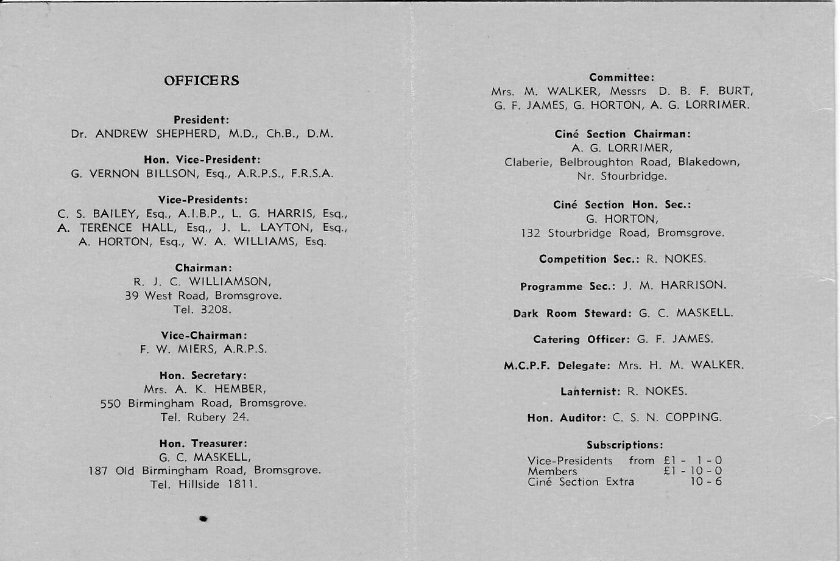
1959/60

16th November 1959
A report was given by Mr. Horton on the Exhibition held recently at Bromsgrove Church Hall. Displays of work by Society members were shown to the general public together with 16mm films and equipment demonstrations. The exhibition had been reasonably successful although it was felt more people would have attended had the advertising of the event been better arranged.

Interclub Competitions – A letter had been received from Kings Norton P.S in which they said they did not agree with our suggestions regarding the inclusion of colour transparencies in Interclub competitions. Committee members thought this a rather surprising decision considering the great upsurge of colour work at Bromsgrove in recent years.
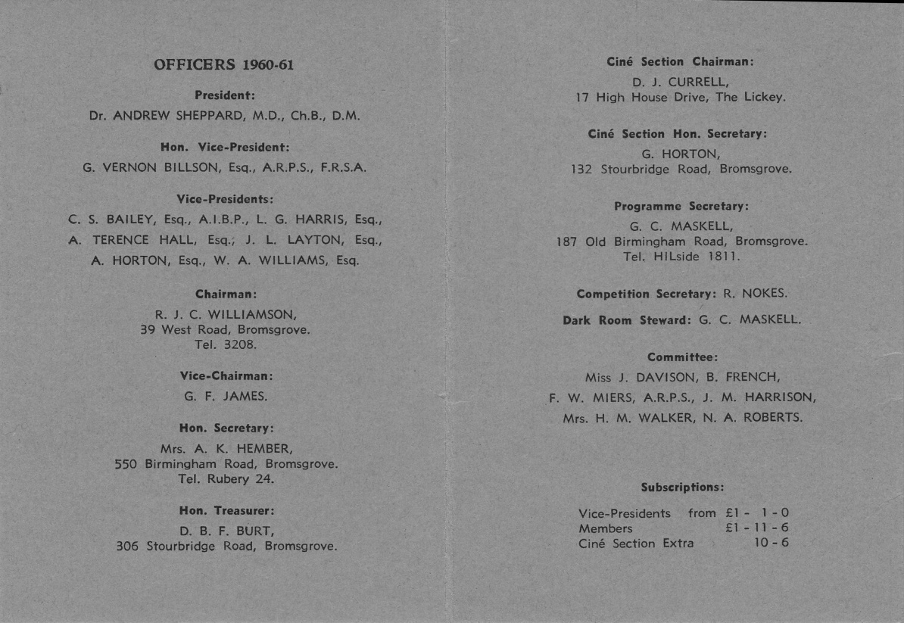
1960/61

Summer 1960
A special meeting was held on 10th June to commemorate the 10th Anniversary of the Society
A selection of monochrome slides taken on the opening night in 1950 were shown together with some of the more recent colour work.
A presentation was made to the Founder Mr. G.V. Billson who spoke of the struggles during the early years of the Society and wished members much success in the coming years.

1961/62
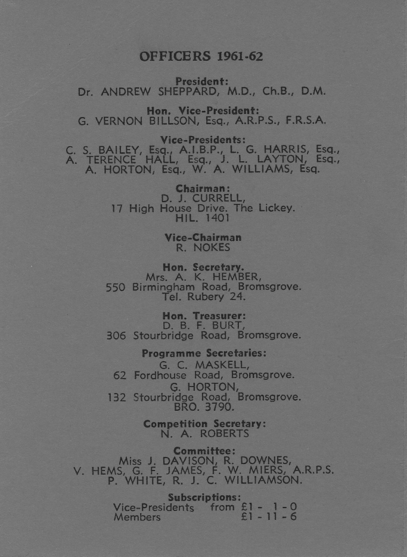

13th February 1961
A suggestion was put forward to the Committee that the Still and cine sections of the Society be amalgamated. It was felt that this move might bring an end to both the financial and weekly attendance problems that still existed.
Mr. F.W. Miers suggested that meetings could be designed to appeal to the widest possible number of members from both sections. He also proposed that there be two Programme Secretaries who could work together to arrange meetings that were suitable to both sets of members.
10th May 1961 (A.G.M.)
24th May 1961 (A.G.M. resumed)
Resolution regarding the Constitution of the Society
The Chairman explained to members the reason why this had been put forward. The Committee had had many discussions on the best way to improve attendances at meetings and as so many of the lectures nowadays were recorded and only lasted half an hour. It Was generally thought that by combining the Programmes of the Still and Cine Sections, not only would the attendances improve but many of the members who were interested in both sides of Photography but found it difficult to attend two meetings each week, would benefit. This would also tend to bring the members closer together.
As the majority of the members were in agreement with the resolution, the amalgamation of the two Sections was finalised with the agreement that meetings would continue to be held on Tuesday evenings.
The 10/6d levy previously imposed on members of the Cine Section was abolished.
1962/63
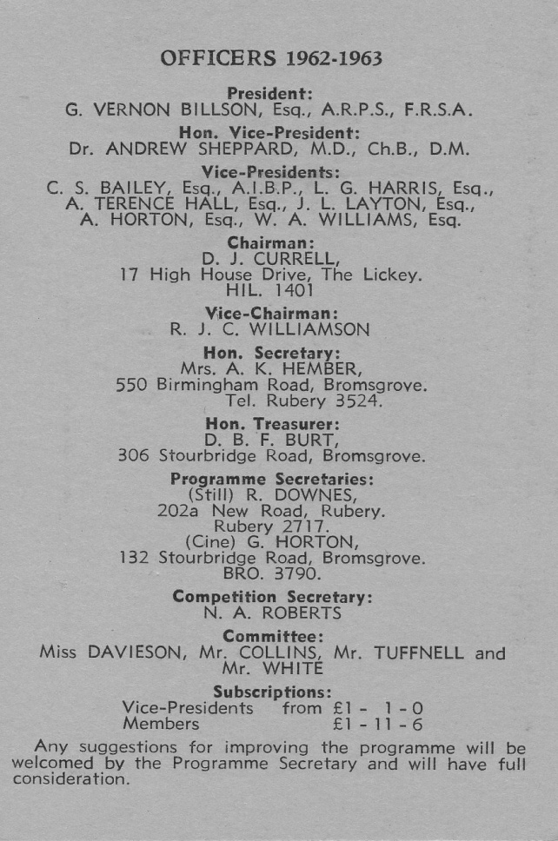

23rd May 1962
Mr. Tuffnell suggested that beginners were being discouraged from entering competitions because they had to compete directly with advanced workers. It was therefore decided to have a special beginners section included in each monthly competition.

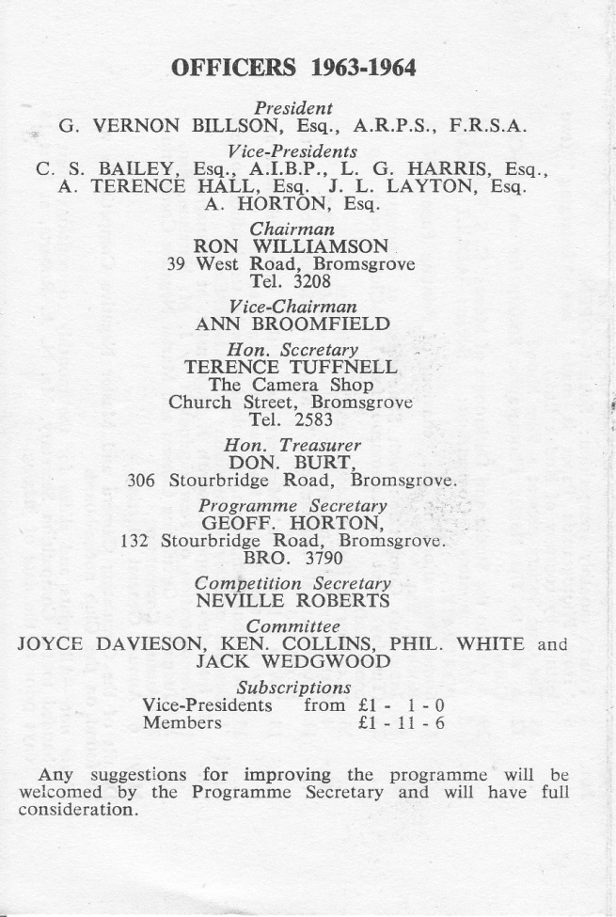
1963/64

8th May 1963 (A.G.M.)
The Chairman reported on a reasonably successful season with weekly attendances up on previous years.
The Cine Section were again holding separate meetings on Tuesdays and attracting 10 members weekly.
A lot of work had been carried out on the Clubroom. A New floor had been laid and the Cine Section had erected the new proscenium.
The Treasurer also reported a healthy state of affairs, making special mention of the Xmas Raffle which had shown a profit of almost £30.
Mr. Roberts as Competition Secretary was pleased to inform the meeting of a somewhat surprising revival in Monochrome work during the year. One key member, Mr. Burt, having transferred his affections completely from colour to monochrome.

1964/65
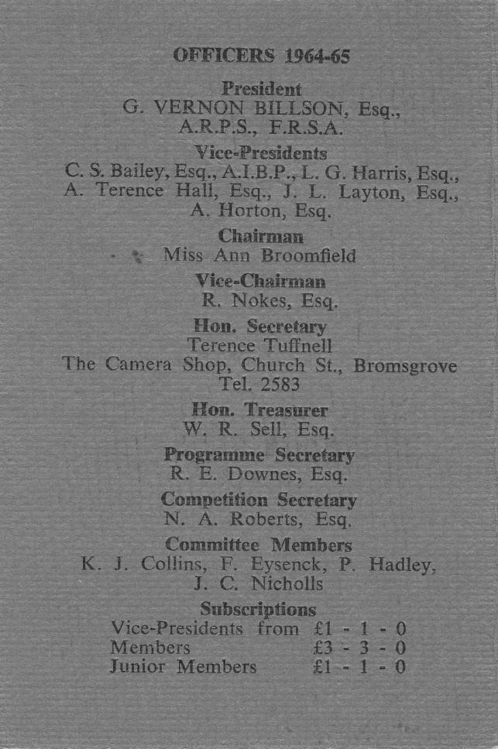

6th May 1964 (A.G.M.)
Chairman’s Report – Mr. Williamson informed members that the Society had received notice to leave the present premises. Mr. Tuffnell however, said that discussions had been carried out with the landlord ever since notification to leave had been received, and it was now hoped that the Society would be able to secure at least a 3 year lease. An increase in rent however, probably from 10/- to £1. Per week was inevitable.
The idea of a probable doubling of the rent and the loss of the Cine Section who had already found alternative accommodation provoked much discussion on matters of finance. May ideas were put forward by members but the final decision was made on a proposal by Mr. J.M. Harrison that the annual subscription be raised to £3-3-0. The proposal was carried by 11 votes to 3.
29th May 1964
Plans were made to re-introduce a Technical & Record Section in both monthly and Annual competitions for colour transparencies. It was also agreed to have a Portrait Section for colour transparencies in the Annual.
25th November 1964
Mr. Tuffnell informed the Committee that he had received confirmation from Messrs. J.A. Brazier Ltd that the future rental for the Society would be £52 per annum.
1965/66
5th May 1965 (A.G.M.)
Chairman’s Report – Miss Broomfield was sad to inform members of the failure of a plan to improve the Club’s finances. During the year the clubroom had been seb-let to the Bromsgrove Bridge Club for an agreed rental of £30 per annum. However, due to complaints from the Landlord’s Mother, the agreement had to be terminated.
Competition Secretaries Report – Mr. Roberts reporting results for the year made special mention of the fact that for the first time ever we had beaten Hagley C.C. in an Inter Club competition.
10th May 1965
The Committee felt that an Honours Board should be obtained and displayed in the clubroom as soon as possible.
Following a proposal by Mr. Eysenck it was agreed that the Founders Cup be presented for the best Monochrome print of the year and that a new award be provided for the best Transparency. Mr. Harrison kindly offered to donate a Trophy for the Transparency award.
It was felt that this would make judging simpler, as in previous years colour slides had to be compared directly with Monochrome prints to find an eventual winner.
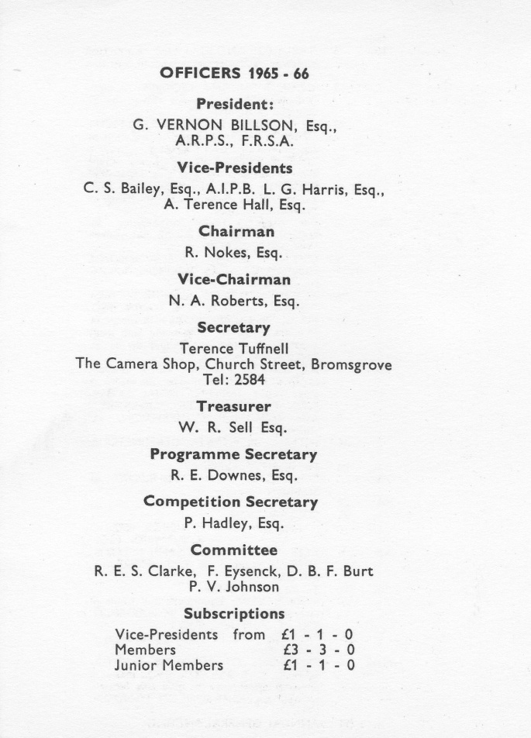

1966/67
11th May 1966 (A.G.M.)
Mr. Nokes, as Chairman, proposed a vote of thanks to Mr. R.E. Downes for the excellent Programme he had arranged for the past year. Mr. Nokes thought that it was possibly the best programme the Club had ever had.
Treasurer’s Report – Mr. Sell presented the Society’s yearly accounts and pointed out that expenditure had exceeded income by some £15-0-0 thus reducing the balance in hand to £32-6-3d.
It was generally accepted that new members would have to be found to help bolster Society funds.
Competition Secretary – Mr. P. Hadley said that the 1965-66 season had been most encouraging result wise. We had won the M.C.P.F. Colour Section for the first time and been successful in Inter Club competitions against Kalamzoo, Kidderminster and Stourport. We had also come second in the Six Clubs Competition, our best position for some time.

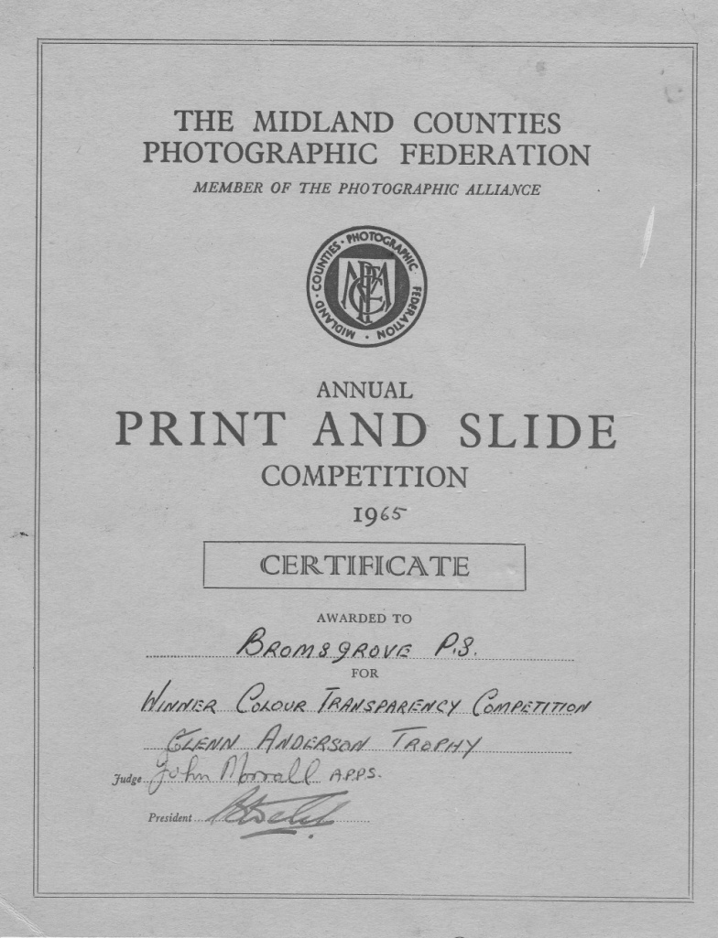

Archivist’s Note – There were unfortunately no minutes recorded from Committee meetings between 1966 and 1969 and so the only details I am able to report on are from the Annual General Meetings held during that period.
1967/68
5th May 1967 (A.G.M.)
Mr. Tuffnell informed members that he had been fortunate to obtain a Leitz Prado projector at a very attractive price. This model, he said, was of the highest quality and capable of projecting 35mm and 2 ¼ sq slides.
The Chairman thanked Mr. Tuffnell for his kind offer and hoped that enough money could be raised to purchase it.
Several donations were made by members at the meeting to help meet the cost.
Treasurer’s report – Mr. Sell presented a slightly healthier balance sheet than the previous year but said that this had only been made possible by income from raffles and other money raising ventures.
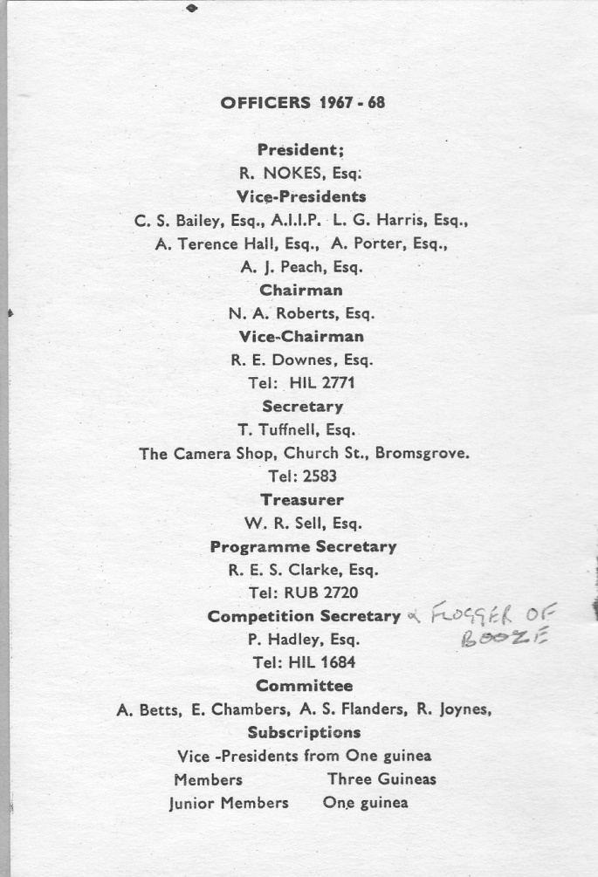

1968/69
1st May 1968 (A.G.M.)
Monthly competitions – It was agreed that for a trial period of one season, judges would be asked to provide us with just a 1st, 2nd and 3rd place for each section and to only comment on the other entries.
The ever popular question of the Society’s Honours Board was again raised but as no progress had been made, the matter was deferred to a later meeting.
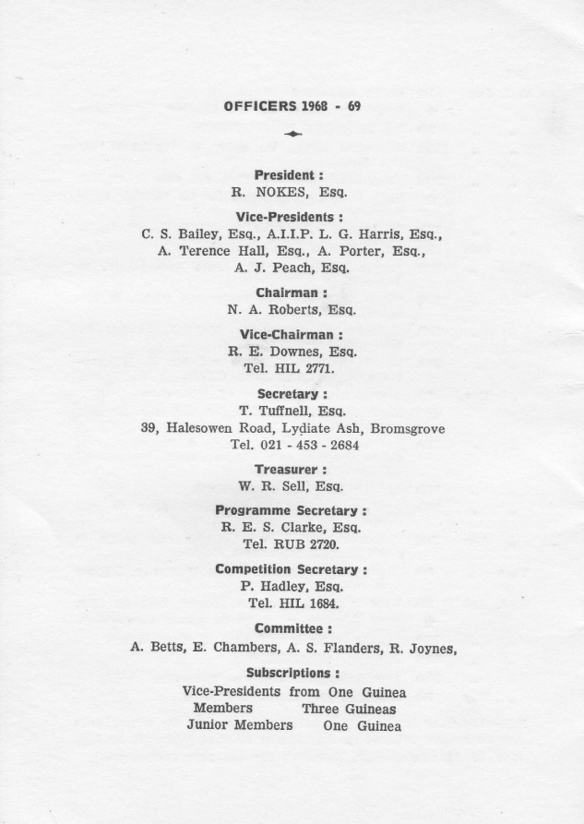

1969/70
30th April 1969 (A.G.M.)
Mr. Nokes, as President, proposed a vote of thanks to the members who had put in so much work on the Clubroom during the close season. Mr. Roberts agreed with Mr. Nokes remarks and said he thought that the Clubroom was almost certainly one of the best in the Midlands.
Treasurer’s Report – Mr. Sell was pleased to report that annual subscriptions were up by almost £30 on previous years. This was due of course to a substantial increase in membership.
Competition Secretary – Mr. P. Hadley said it had been a very good year competition wise. We had won the Six Clubs competition for the first time and also beaten Worcester Camera Club, in our first ever Inter Club battle with them. Five entries from Bromsgrove members has also been accepted in the Sutton Coldfield Exhibition of Midland Photography.
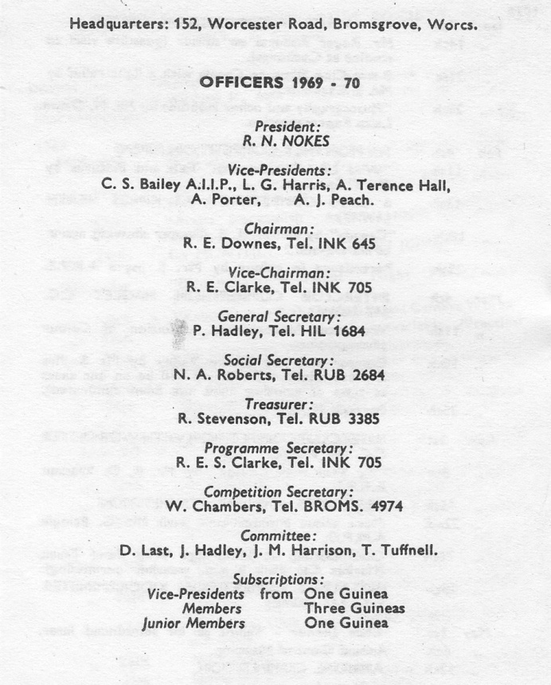

1970/71
24th February 1970
Mr. J.M. Harrison brought up the subject of changing the name of the Society. He thought that “Photographic Society” sounded a little too formal and that “Camera Club” was a more fitting title for what is essentially an informal organisation. The Committee in general agreed with Mr. Harrison’s idea but felt that any change in the name should be carried out after the 21st Anniversary celebrations in 1971
Much time was spent discussing the system of marking competitions. Many members felt that the idea of completely dropping one month’s marks was unfair to those who took the trouble of entering every competition.
Eventually, however a proposal put forward by Mr. Downes was accepted by the Committee and consisted of the following:
A) A bonus point awarded for every entry
B) 10 points for 1st place, 6 Points for 2nd and 3 for 3rd
C) All points doubled on a set subject
D) Marks from all monthly competitions to count towards the annual aggregate awards

9th March 1970
M.C.P.F Exhibition of Midland Photography held at Sutton Coldfield.
For the first time in the history of the Exhibition, Bromsgrove Photographic Society was awarded 1st place in the Championship for Transparencies. This was a magnificent achievement for such a small club against opposition from all over the Midlands.
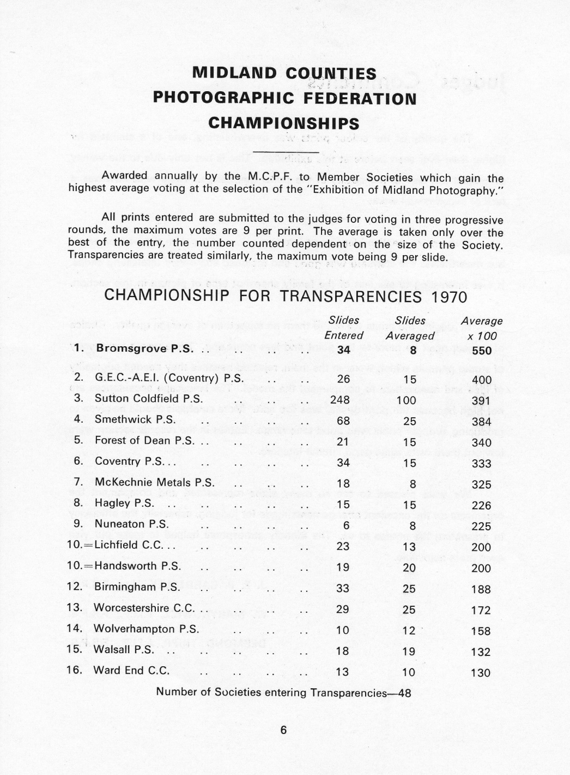

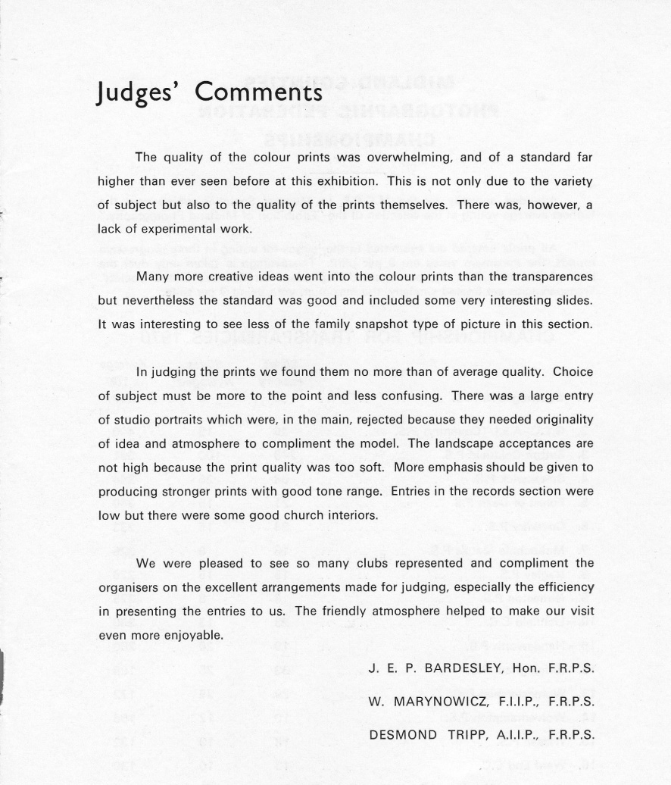

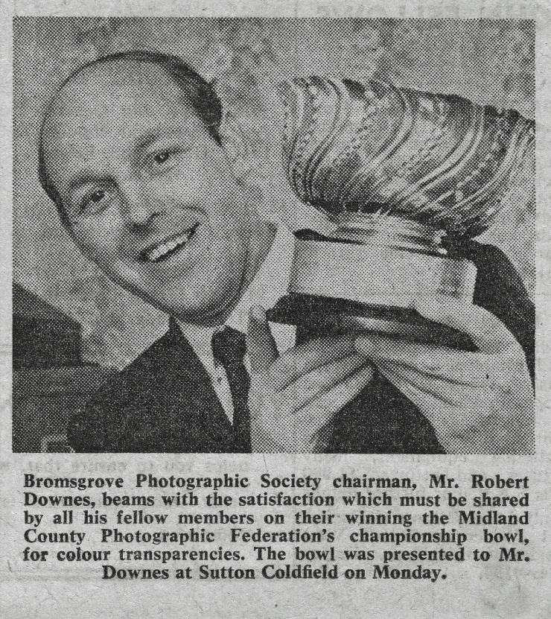

11th March 1970
At the Dolphin Suite, Bromsgrove Swimming Baths, the Society held a public showing of the Worcester Camera Clubs Eighteenth International Exhibition of Colour Slides. Tickets had been sold over the previous months to the general public and other photographic clubs, with a result that nearly 250 people turned up for a very successful and entertaining show.
The Exhibition consisted of both Pictorial and Natural History colour slides from exhibition all over the World.
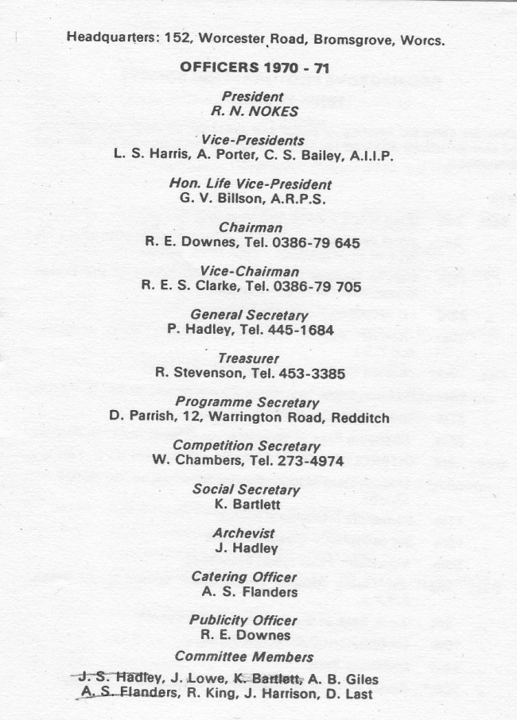

6th May 1970 (A.G.M.)
Chairman’s Report – Mr. Downes was pleased to report on what he felt was probably the Society’s most successful season ever. He thanked members for the effort they had put in during the season to make it such a success.
Competition Secretary’s Report – Bill Chambers was able to present a glowing report for the year making special mention of our 100% success in Inter Club Battles and also of course the tremendous win at Sutton Coldfield.
For the first time this year, a special competition was held to find the best beginners work for the year. This was called the Beginners Annual and was won by John Stroud for Colour Slides and F. Morton for Monochrome.

The 1970 – 71 season was, upon reflection, not one of our most successful in recent years.
Attendances at meetings were down on the previous year due possibly to the unfortunate departure from the area of some members and the non participation of others who in years past had been considered as regulars.
The programme was well up to our usual standard containing a balanced and varied selection of lectures, competitions and practical nights.
One disappointing aspect of the year’s programme was in competitions, usually one of our stronger points. The quality and more so in the advanced section the quantity of entries was well below the standard set from previous years. This fact was further amplified through our lack of success in international competitions and that for the first time in three years we lost our Inter Club battle with Worcester Camera Club.
Certainly worth a special mention from this year’s programme is the fact that for the second year running we presented the Worcester International Exhibition of Colour Slides. In spite of the postal strike and the co-operation of the Worcester C.C. Committee we managed to present a reasonably smooth and well organised show to an admiring public.
Monthly Competitions – Six monthly competitions were held during the season including one set subject and one devoted entirely to Technical and Record work. A new marketing system came into force during the season and operated like so;
10 points were awarded to the winner of a competition.
6 points for second place
3 points for third place
In addition to this, entrants were also awarded 1 point for every entry and the marks gained on a set subject were automatically doubled.
At the end of the season member’s individual points were added up to find winners in each section.
The Annual Competition this year was something of an occasion being judged for us by Mr. H.R. Thornton F.R.P.S. He provided us with what must have been one of the most competent and certainly the most entertaining pieces of judging the Society had seen for many years.
The one monthly competition reserved entirely for Technical and Record work was judged by Mr. A. Wharton who gave us some very useful pointers regarding both and also presentation in Technical and Record work.
Only one member entered work into the M.C.P.F. Exhibition at Sutton Coldfield. Ralph Williams had his slide “Mischief Brweing” accepted.
One sad note on the year’s activities had been the necessity to create a bottom age limit on the Membership. This had been forced on the Society by the presence at the Society’s nights of very young children of members. It is not natural for youngsters to have to sit still for the duration of lectures and competitions etc.
The finances of the Society took a turn for the better. On 24th April 1971 there was a balance in the Bank of £135.
Trouble with the Electricity bill – M.E.B. claimed we had used double the power over the previous year. We claimed we were paying for Bromsgrove street lighting.
Christmas Party was the usual success showing a profit of over £6 due to Rob’s persuasive selling powers.
It looked like the end of our competition marking troubles, at the A.G.M. a motion was carried whereby the highest mark scored by each member at each and every competition would count! It had taken many years to get back to normal.
Rob Downes and Mrs. Green presented the Society with trophies for “Aggregate” marks to be awarded to the members maintaining the highest average mark for all entries.
1971/72
The Society’s 21st Year
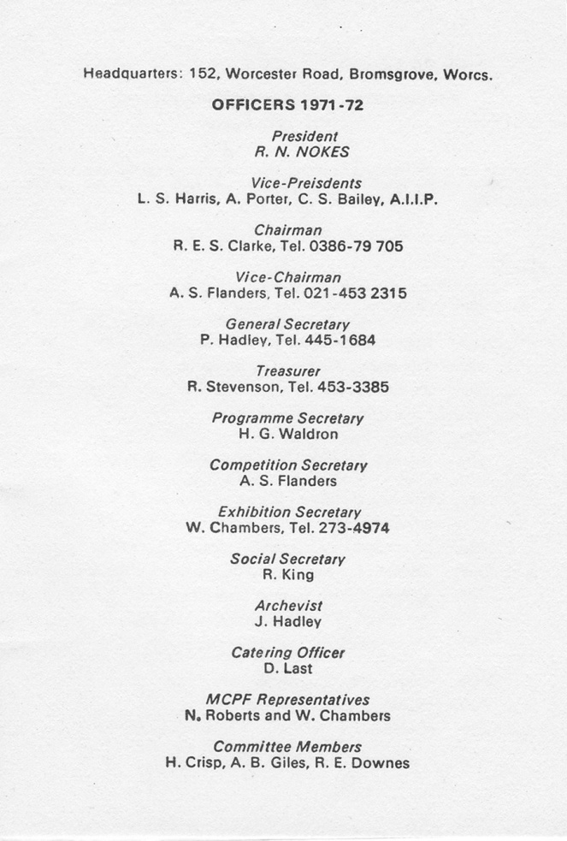

During the Summer break, the Committee had to work hard to prepare for the 21st Season.
All the electric wiring was overhauled and a “ring mains” was installed by T. Tuffnell and helpers.
The staircase was boxed in on instructions from R.E.S.C. who supervised all the work – without breaking into a sweat!
A small changing cubby-hole was fitted out at the side of the screen for the use of potential “models”.
The ceiling over the bar was lowered over where the joints showed through and the darkroom was cleaned out.
To achieve all the above, members worked very hard on the organised “working parties” on Wednesday evenings and Sunday mornings – the latter in spite of violent opposition from the Scottish immigrants downstairs”
A severe blow to our fortunes was delivered by the new rating Assessments. Hitherto we had not been liable for rates but due to the presence of a commercial venture (Car Care) we had to pay nearly £40 per annum. This as well as the new cost of electricity 3.75 per until (£2 -£3 per eveing) caused an Extraordinary General meeting to be held.
Much effort, pen pushing and pleading by the Chairman and Hon. Secretary eventually got a rate reduction of 50%. We claimed we were a semi religious educational, cultural organisation and claimed diplomatic immunity and got it!
The 21st Anniversary of Bromsgrove Photographic Society was celebrated at the Dolphin Suite in fine style. A great show of member’s slides old and new and also prints were on exhibition
Bill Chambers and other members sorted the slides (about 500) and put them to music and suitable verbal commentaries by Rob Downes. A license was obtained and a bar was run by courtesy of the “Park Gate” public house.
Our Founder Member, G.V. Billson A.R.P.S. was guest of honour. Also present were the president of M.C.P.F. John E. Burgess and Council member B. Welch. Members of the public were invited at a fee of 15p.
The evening of November 3rd was a great success.
The season in spite of a bad financial shock, recovered and proved very enjoyable and successful from all points of view.
The increased subscriptions had covered expenses and there still remained a healthy surplus at the Bank
Competitions had proved better than last year and standards were very good –except Black & White.
There were only two Inter Club competitions both of which we won.
A note here, Fred Morton had won the Beginners Annual Colour award – 3 years running.
At the A.G.M. members elected the following as Hon. Members for services to the Society.
Mr. Copping, Mr. Sell and Mr. Mansell.
George Vernon Billson A.R.P.S. was elected the Hon. Life President.
The annual Dinner and Prize Giving was held at the hostelry at Mustow Green for the second time.
1972/73
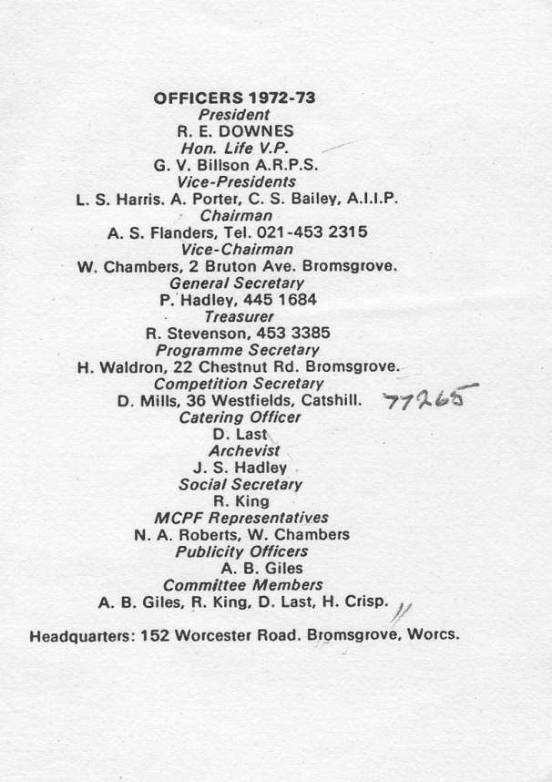

For the first time an effort was made to organise a proper programme for the Summer recess.
Individual members were made responsible for each evening by suggesting and then organising the activity. In retrospect it was a great success in keeping members together and holding their interest.
Some highlights were: the outing to Worcester Cathedral (Bud), The Botanical Gardens (Bud) Rob Downes’ demo on Ektachrome processing, Figure Study evening (Dave Mills) etc etc.
Many shutters suffered metal fatigue or were burned out during the Figure Study night. There is no truth in the statement that there was no film in the cameras.
The Season proper started with Rob’s usual “bring & buy” sale and buffet bar. Rob was in his usual money grabbing form.
Howard Waldron’s first season proper as Programme Secretary showed great promise with some “big names” as visiting lecturers. These together with other star attractions made up probably the best programme in 22 years.
The Society started a series of small adverts in the Messenger and the Library which bore fruit in the shape of new members.
We also put on a slide show at Lickey Parrish Hall in aid of the Youth Fellowship.
A very non-photographic event was the annual Beer & Skittles at the “Bell”. A full house enjoyed a great evening with Rob keeping a semblance of order. Not a camera in sight.
The Christmas Social again a great night due to a lot of work by the Committee and members. Once again Rob was in good heart and voice as M.C. What would these occasions be without our worthy President?
Don Last and his wife again did us proud with the grub stakes at the party.
The attendances during the season was easily the best ever. Don Last again to the fore with 35-40 cups of tea every week – all done with a smile. The most important members.
Rob Downes and Bob Clarke gave a lot of their time and energy to other clubs in the form of judging and lectures etc.
Due to the high cost of electricity, we purchased two paraffin heaters – these proved very successful and cheap.
On the Competition side we had 3 Inter Clubs v Hagley, South Birmingham. We won them all.
90% of the members had participated in competitions of all sorts. The standards of the so-called “advanced workers” was well down.
In addition we had come a moderate 4th in the 6 clubs and a creditable 3rd in the M.C.P.F.
A very successful year.
1973/74
Another successful Summer programme was held and received plenty of support.
A visit to Worcester Cathedral again produced plenty of scope. This year the Hon Sec didn’t expose his masterpieces to the light before developing.
Pete Neale showing the enthusiasm of youth in his efforts to secure mountaineering masterpieces, fell off a rock and broke his leg! The Competition Secretary would like to see other members show the same keenness.
The Kodak processing strike caused problems for the transparency workers but didn’t prevent the usual enthusiasm for the competitions.
Howard Waldron produced another cracking programme for the Season proper which got underway to a very quiet start.
Member Jim Puddephat showed us that he is not just a pretty face by giving us a slide lecture on his work. As Automobile Body Stylist.
Founder, George V. Billson came on 31st October with his show “Pictorialism as a form of self expression”
J.H. Thornton – the great – followed up with a superb exhibition of his work on Agfa Film.
The Christmas Social was held (in spite of the Miners Strike, Power Cuts etc) for the first time away from the clubroom. The village hall at Bourne Heath was the venue. The Committee and members joined in to make it the usual success.
A black day on 27th February when the Society lost their first Inter Club (Colour) for about 5 years. South Birmingham P.S. were the victors. It is thought that Dave Mills is saving our best for something special. More murky days followed with the Society only getting a draw vs Austin and Entaco and a disgraceful loss vs Hagley. Where were all the decent prints and slides seen during the season?
Mrs. J. Marsh worked hard at her photography to such effect that she won the Beginners Monthly.
Cliff Gamage won the Beginners Annual in Monochrome with Roy Fisher getting the Colour Award.
The Annual Open of 1974 produced two new winners – a good thing for the Society.
Harold Crisp operated his Nikkors to such good effect that he produced a deserved winner with a superb colour slide to win the Harrison Trophy.
John Reakes celebrated his appointment to the Treasury of M.C.P.F. with a win for the Founders Cup.
A.G.M.
The AGM was the usual hilarious procedure for which BPS has become justly famous! Two new sections were formed for competitions. Intermediate Colour Slides (Not enough for B&W) and colour Prints – an attempt to keep up with the Jones’s?
After many years trying, Brian Giles succeeded in breaking down the barriers of the Messenger Office to such purpose that we are now getting weekly reports of the Society meetings – well done Brian.
This year, by request, the Annual Dinner and Presentation included a dance after the eats. By all accounts a resounding success. Lack of Pictorial evidence of this due to absence of theHon Sec. and Nikon! However at least one picture must have been taken as there was a distinct likeness of the worthy President handing out “goodies” in the Messenger.
All in all another good year, enjoyed by all.

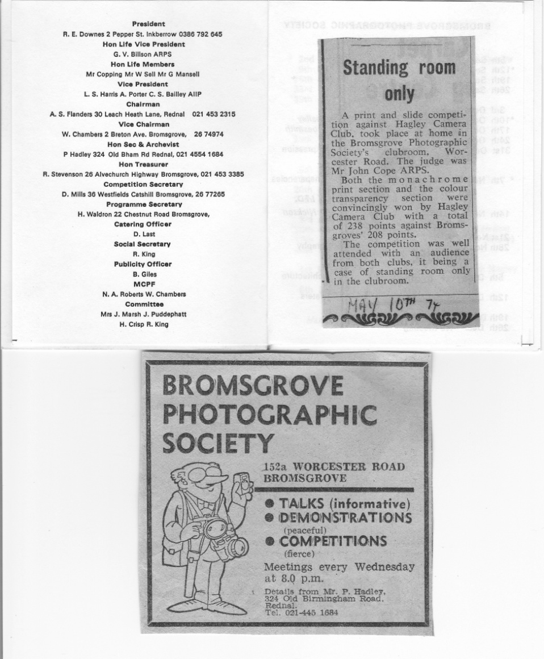

1974/75
A less well defined Summer Programme was held, there being a few blank Wednesdays. Some members always seemed to turn up at “152” even if only to “natter” and put the Photographic world to rights.
Bill & Steve did a grand job of replacing a few square yards of the clubroom ceiling which had obeyed the law of gravity due to old age and rusty nails etc.
Visits to Worcester Cathedral, Botanical Gardens, the boats at Upton Warren and the Bromsgrove Museum at the Old Schoolhouse were some of the attractions on offer. At the Museum, some members tried to part exchange their photo and Hi Fi with some of the stuff on display – it was better than theirs!
Bromsgrove Council decided to hold a “Sport for all” programme in Sanders Park on 3rd August. They approached the Society for a contribution – practical, not financial –but due to the fact that most of the members were sunning themselves on holiday in the Med or elsewhere, it was rather a problem. We did however manage to put on a display of trophies and prints and handouts in conjunction with the camera Shop. The Hon. Sec. even put his precious Nikons on display – please do not touch!
The last job of the close season was selection of entries for the formation of the new Intermediate Section.
The Season proper again started with a “bring and buy” sale where folks could buy back the rubbish they had donated the year before. Some items have made an annual appearance for at least 10 years.
Another superb programme arranged by Howard Waldron got away to a good start with Bert Hoody on 18th September.
Carol Mason showed the mere males just how easy it was to produce 20 x 16 colour prints without any practical knowledge of photography – so she said!
The following week our own Jim Harrison brought 2/3rds of the Durst factory to prove just how difficult it was to produce what Miss Mason said was easy.
Another visit from V.T. Jackson of Cheltenham on 6th November giving his “World of Colour & Sand” confirmed our impression of his first visit – he’s great.
Roland Reed, Bert hardy and Ian Platt saw 1974 to a worthy close. The only dull spot being the sponsored visit of Colin Garratt of Pentacon who we thought “all talk and few pictures”. Which only shows what you can do with little technique and a gift of the gab! He also cost us about £9-00.
The Christmas Social was its usual success – thanks to Ron King. It was once again held at Bourne Heath.
On 22nd January a near tragedy happened when the star of the show, John Podmore failed to put in an appearance. After a phone call to his home, he arrived full of sorrow for his oversight, but more than made up for it with his show – a great Midland photographer.
Possibly the finest evening’s entertainment in the history of the Society was the visit to us of B.J. Franks on 29th January. A master with the camera both in his work and hobby and a similarity to “Blaster Bates” with his line of patter.
A 2nd placing in the “6 Clubs” competition waqs an improvement on previous years.
On 18th March the Society were hosts to the Kodak “Colour Viewpoint” with Richard Wilson in his usual superb form. Held at the “Dolphin Suite” and a great success.
Bob Clarke treated us to a show on 2nd April. Many of the newer members had never seen his work before and were greatly impressed – as were the rest of us. We would have liked to have seen more of RESC!
The new Beginners Annual was judged by Rob Downes who suggested that the “Advanced” members should look to their laurels.
The A.G.M. was a sad affair for the older members as it was voted to leave the old premises at “152” and move out to Avoncroft Arts Centre at the end of the Season.
A Dinner Dance was held at The Lenchford Hotel.

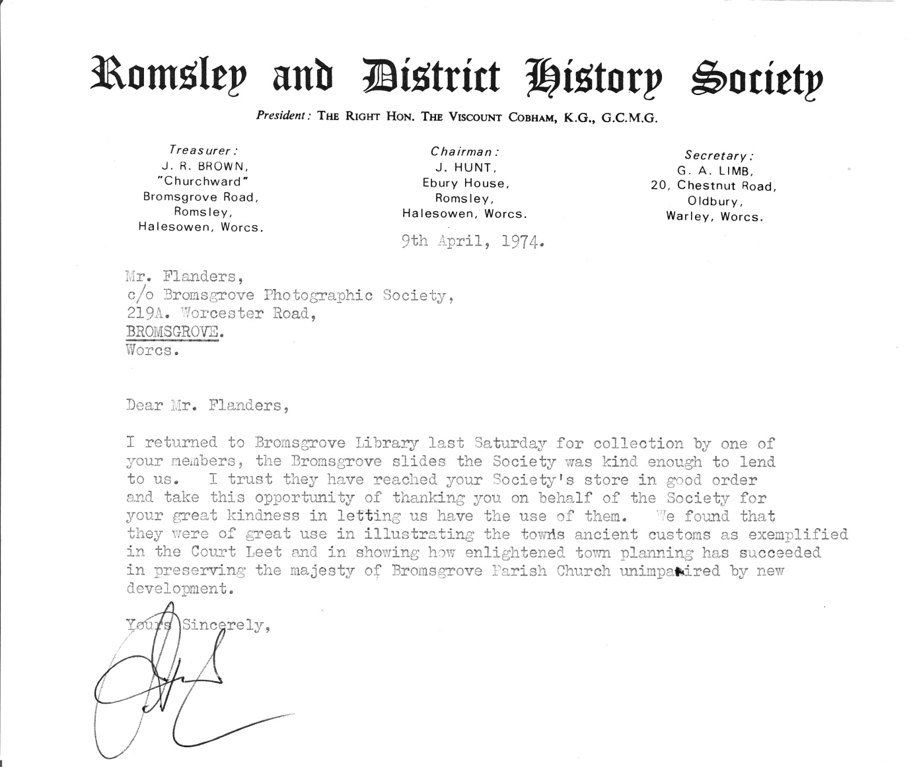

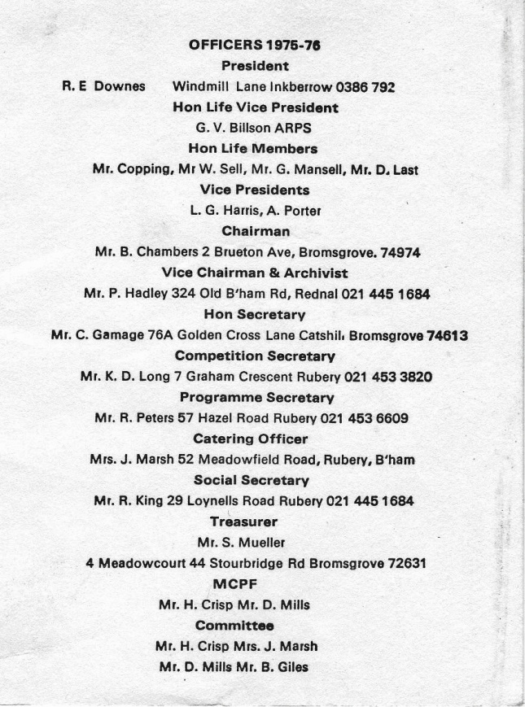
1975/76

The Summer started with the sad work of leaving the old clubroom. Removing and selling off all the tuff not needed at Avoncroft. Things will never seem to be that same without the atmosphere that our own “152” gave us.
It was after the .G.M. that we decided to go mad and spend all our funds on a new slide projector, a Leitz Pradovit Colour 250 no less with a 150mm lens. We still keep the old Prado push/pull in case “N.A.R.” wants to do 2 ¼ sq !
Much work was done behind the scene by Chairman Bill Chamber with the Avoncroft hierarchy to decide who does what and where. Some clashes were foreseen with the Drama Group over use of the large Clubroom.
One or two photographic sessions were held at the new rooms with models – one with clothes and one without, the latter proving much more popular.
Members were to have met for a walk along the “Cut” at Stoke Works one evening. Most of the enthusiasts remained in the clubroom with their cameras. Only A.S.F and P.H. had the endeavour required and shot off a roll apiece.
And so to that start of the 1st Season in our new rooms with plenty of car parking space for those who can afford the petrol. A posh kitchen to brew up – with Ron King’s son fully paid up tea maker under Joan Marsh’s eagle eye.
Attendances are keeping well up in spite of the distance of Avoncroft from the old place. Many new faces showing up – a good response from the advert in the Messenger in its new form.
The 1st Monthly competition was notable for the high standards of work in the lower classes and the poor work in the Advanced. Many red faces!
The expected clash with the Drama Group came to a head on the 14th October who wanted to turn us out at short notice. The Vice Chairman, together with the redoubtable Miss Foster, sorted things out. The first round to the Society.
The one and only H.R. Thornton – by kind permission of Agfa – Geveart – came to Avoncroft on 21st October. His comments on the size of our temporary screen had to be heard to be believed. “who’s hung that *!!** handkerchief up there? He overcame the disadvantage of the handkerchief and showed us how a 65+ can tour the World on an old tandem. What a character!
The 2nd Monthly was a very poor show. Some of the poorest work sen at Bromsgrove for many years. The judge matched the show very well.
Tom & Hetty Nickson brought their new-style show on 18th November. “The Third Image” with Leitz Animatic dissolve system. This was in the opinion of some of the older members the finest show seen at Bromsgrove since the Society started. The 3rd image being made by the twin projectors. A truly memorable evening.
On 25th November Tony Wharton BA.ARPS.AFIAP etc. etc. showed us what can be done with a Pentax and some “Bugs”. Superb Natural History work with a good knowledge and love of his subject. Members of Worcester Natural History Society were invited.
The Christmas Social was held for the first time at Avoncroft in the large clubroom and by all account was well attended and much enjoyed by one and all.
Inter-Clubs competitions against Stourport and Redditch were held with mixed results. We seem to have lost our winning touch.
Dave Parrish – an old Society member - returned on 27th January to show how he did his “table top” photos and slides and then invited members to “have a go” themselves.
An impromptu Portrait Evening was held the following week. Members had the “use” of Dave Mills beautiful daughters who sat for the happy snappers with great patience. They don’t get their good looks from Dad.
10th February was the long awaited President’s evening. With his usual low cunning, Rob Downes persuaded a friend of his to give a slide talk about Jacobean Glassware and his technique for photographing glass. Rob produced 2 new GAF projectors with all the gimics and fiddles. Fade in, fade out, forwards, backwards and sideways. A good show was put on with some nice slides by Roy Peters. In spite of the high standards of the evening’s entertainment, it was thought that the Hon. President had not lived up to his reputation as a giver of organised chaos! However, towards the end of the evening the lighting blew up and all plunged into darkness with great panic. That was more like it Rob!!
On 17th February Ray Dowding brought his wonderful Audio-Visual show which reduced the members to google- eyed envy.
Dave Simmonds made a very welcome return to Bromsgrove with a show of his fabulaous F.R.P.S prints.
The Beginners/Intermediate Annual was judged by the Vice Chairman (P.H.) with an unusual display of sobriety. A very fine display of prints and slides to put the seniors into some shame.
John Podmore was the judge at the Annual “Open” competition. Colin Hutchly gave the biggest bribe and won the Founders Cup – he would have won without the bribe anyway. Roy Fisher got the Harrison Trophy for colour.
The usual Dinner Dance orgy took place again at the “Lenchford” organised by Ron King.
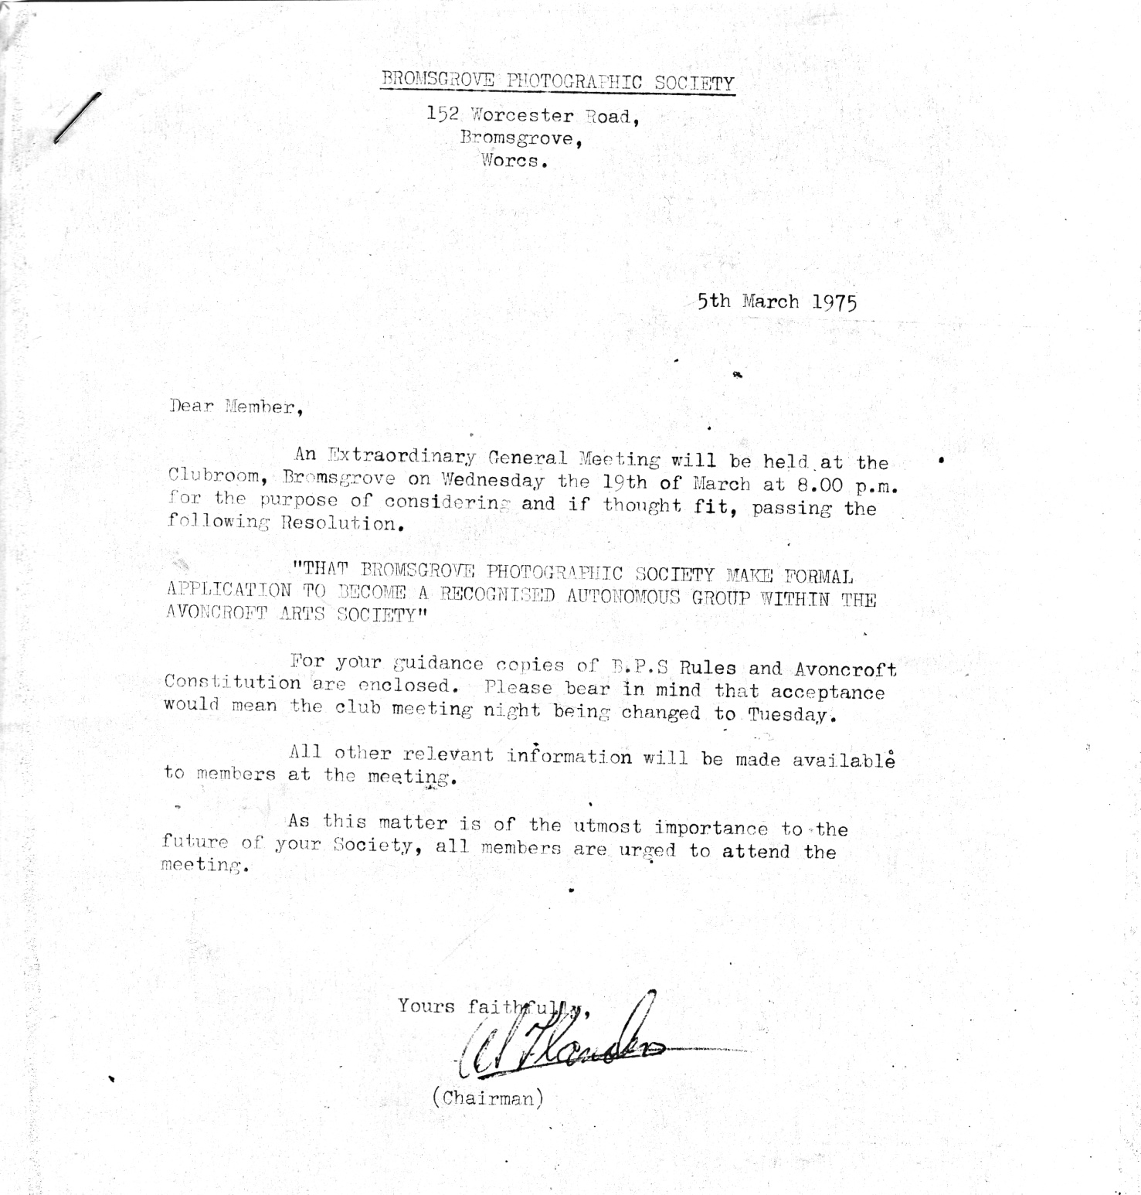
So ended our first full year at Avoncroft. We have settled in well and all is success.

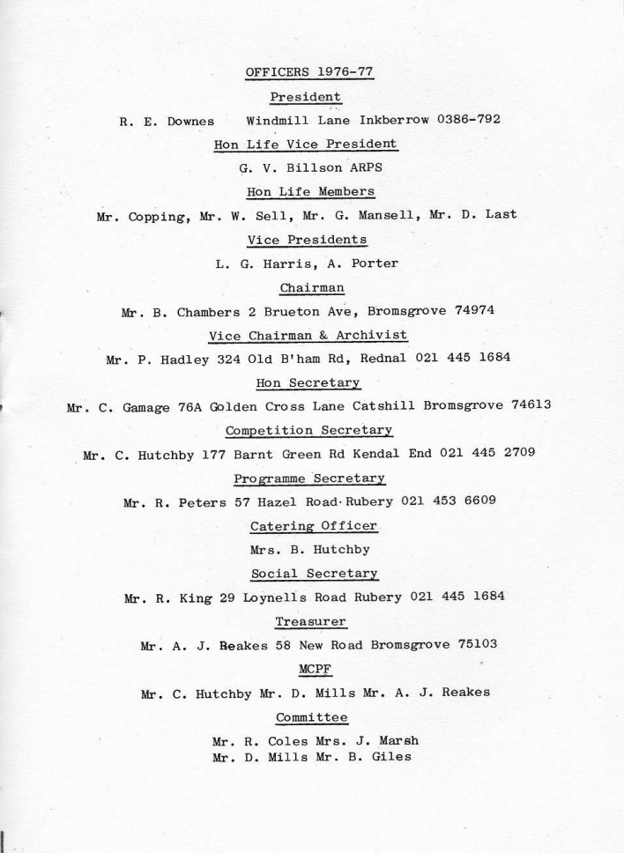
1976/77

The Summer Programme started with a demo of the Cibachrome colour printing process by Jim Harrison. Most impressive and sure to get a few converts in spite of the great cost.
Several working parties were organised during the Summer to reduce the height of the grass and to lay slabs etc.
Portrait sessions were held on two or three evenings- we don’t seem to improve very much in this sphere.
Bill Chambers organised a slide show on a float at the Folk Festival & Sport for All events.
A visit to Whitley Church & Hall on 22nd June arranged by Charles Williams had about 15 of so turn up.
An evening was set aside to entertain some of Bromsgrove elderly and disabled folk on 24th August in conjunction with Bromsgrove Red Cross. It was much appreciated by a non-critical audience.
The new Committee is functioning well, with duties of Hon Sec. being very well done by Cliff Gamage. His tuneful Celtic prose and highly efficient typing of anything capable of being put to paper is a revelation.

7th September 1976
So starts another season proper with another “bring and buy” sale plus cheese and wine nosh up. Rob Downes again persuaded members to part with hard earned “lolly” to the tune of over £20.00. Some of the old favourite that seem to turn up every year to be auctioned were sadly missing. Perhaps their new owners really wanted them!
The Society played host to the M.C.P.F. Quarterly meeting on Saturday 11th. It’s very good to have our own premises large enough to do this service for our governing body. It must surely raise our status.
The “new look” Programme was a shade late in making its debut but thanks to John Davidson,, it was all worth waiting for.
September 21st was another good night for the D.O.M’s! A professional model – Miss Julie Dawn – was duly arranged before the photo floods and white hot shutters. What a popular evening!
Due to the clubroom being occupied by another branch of Avoncroft, the 28th September meeting was held in the re-conditioned pub “The String of Horses” in the Museum. It is a very fine room and was much enjoyed by the Society and Mr. Neville Jackson who issued us all with glasses to view his 3-D work on “Offas Dyke”
The inimitable Bob Franks with his long suffering and loving wife came on October 5th. His workmanship is beyond criticism and his showmanship superb. A great evening with a great guy.
Mr. Laker came all the way from Lydney with his slide/sound show of the “Forest of Dean”. Ths how content was good without being great but the main interest was in the equipment. The fade unit was home made out of odds and sods for a cost of £5! It seemed to work just as well as units costing twenty times as much.
A new innovation on the 2nd November was “It’s a Knock Out” 8 teams of 3 members from each class submitted 12 slides to 3 Judges. The top few teams going forward to a future date. The evening was somewhat spoilt by Colin Hutchby who was taken il and removed to Bromsgrove General Intensive Care Unit with a “dicky ticker”. Too many fags! plus the strain of using a Minolta. Get well soon Hutch.
The 2nd Monthly Competition was judged by A.C. Payne of Sutton. It was notable for some really superb slides, the winner by Keith Long was as good as any seen at Bromsgrove. Hutch won the Mono print from his sickbed.
“Watch this space” on Nov 6th turned out to be President’s Night – a Rob Downes special – a mixture of the improbable and the impossible explained as only Rob can do it. For the more defeated and shattered members Rob and Jean provided cheese and biccies, sausage rolls and cake to go with the tea. Thanks Rob.
The M.C.P.F. Portfolio arrived on 23rd November but only just in time. It was well worth while waiting for. The prints were fantastic and the slides excellent allowing for the fact that they were copies of the originals.
Inter Club on 39th November v South Birmingham. We won the Prints and lost the Slides and the overall competition. Fancy Bromsgrove winning the Prints!!**!
Dear Aunty Doris Handley did us the honour of judging the 3rd Monthly. It was noted by Rob and others (?) that she was not to be so easily swayed from her purpose and marks. She must be getting hard in her later years.
On December 14th members were invited to give a slide/sound show in preparation for a forthcoming Inter Club Competition. The Friday night wallahs put on a good, but somewhat dis-jointed effort, which still requires a fair bit of work yet. John Davidson presented a last minute effort, two to be precise, which was musically and visually superb. He claimed he had strung it together one night when he had a couple of hours to spare.
21st December. Christmas Party Night. The usual rave-up, well attended and well enjoyed by all. Thanks to Ron for all his hard efforts and to the ladies for cakes etc.
Several Inter Club competitions were held against normally inferior opposition, Hagley, Redditch, Droitwich, Stourport etc. Sad to say we didn’t do very well mostly due to not having the best entries available at the right time.
On March 1st The Old v The New! a new competition. The judge had to give the verdict to the “New” as afterwards it would have been a retrograde step. Amongst the so-called members were some very questionable entries to say the least. A good night and well enjoyed.
A coach was hired on March 15th to go to Sutton Town Hall for the M.C.P.F. and Worcester International. It was thought that standards in the M.C.P.F. colour slides were down and also Mono Prints. However, the Worcester International was its usual incredible display of superb photography.
The 6th Monthly (Technical & Record) Competition was again poorly supported and standards were a shade down.
A selection of films (16mm) from Kodak was shown on 29th March – Not very good and not to be repeated. – I hope.
Back to the 8th February and Mr. G. Stone with “Something Different”. A superb collection of slide/sound sequences with lots of “fiddled” slides etc. One to remember for a very long time.
19th April, an evening with a local author, poet “Francis Brett Young” – Too many words and not enough to see. Still a good chance for a snooze!
And so to the big event of the season, The Annual Competition. Judged by Tom Nickson in place of Ian Platt. The Colour Slide competition was again won by Roy Fisher with another Natural History “bug”. Joan Marsh was almost reduced to tears of joy when she won the Founders Cup with a good shot of one of Kodak’s Scottish Castle – the most popular win of all I think.
The A.G.M. saw the chopping and changing around of the Committee. A sad blow was the loss of Bill Chambers as Chairman, happily still available on the Committee with help and enthusiasm.
A reluctant Vice Chairman P.H. was promoted to succeed Bill after some pushing and shoving. Harold crisp will be the new Vice Chairman.
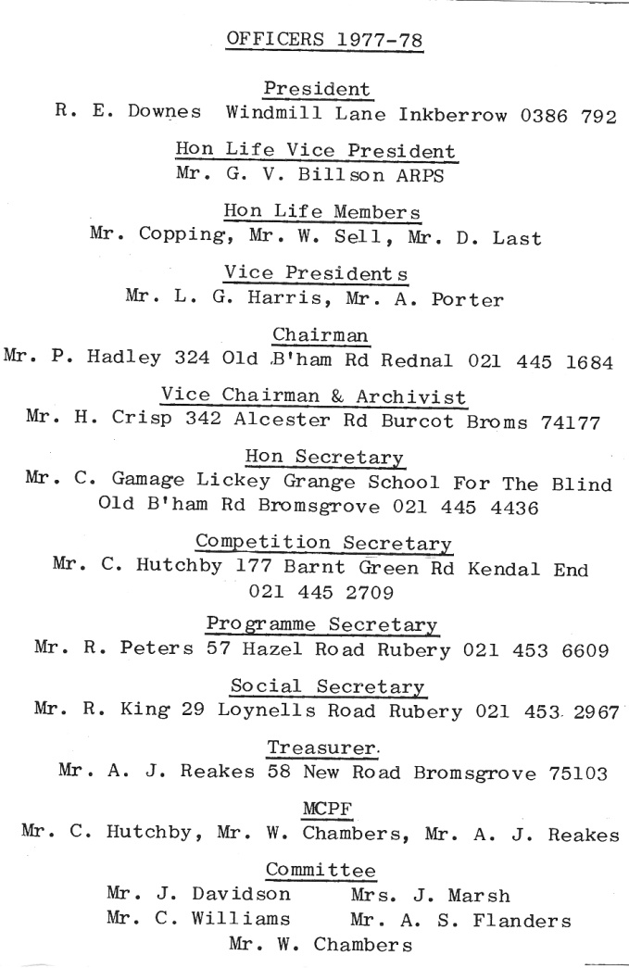
1977/78

Summer Season
Started off well with John Reakes regaling us with approx 10,000 slides of his holiday show with twin projectors and some appropriate music.
May 13th was the Annual Dinner/Dance and Gong” presentations held at the Lenchford. From eye witness accounts it was the usual success organised with loving care by Ron King.
Reg Adey produced a “model” on the 17th May – not a pretty sight. There will certainly not be any prints of her in the monthly competitions.
The Hon Chairman held court on May 31st with an illustrated talk on “Wines”. I feel that the members were more impressed with the “free samples” offered than the Chairman’s Diploma backed knowledge.
A slow walk along the “cut” on June 21st produced some good clean fun but not too many pictures I fear.
Three mini competitions with set subjects “Windows, Actions, Fabric & Fibres” produced some very good efforts and they were really worth-while and well supported.
The Beer & Skittles annual event was held at a new venue, The Glovers Needle, a rather swish and modern pub without much atmosphere, still it made a change.
Some evenings were just spent nattering in the clubroom or over the way at the Grasshopper by courtesy of Ansells Ltd.
The last night of the Summer Sessions produced a portrait evening with two very pretty girls which was a success.
Winter Programme 1977- 78
And so to the start of the new season and the traditional “Wine & Cheese and Bring & Buy” with the Hon President at his best. Much booze was consumed, cheese and biccies eaten before the sale. Rob said it helped to loosen the pockets and purses! Over £40 was raised to help the funds.
September 20th and another “Model” evening. A young lady of Page 3 fame was hired at great expense. Much film was used up. Sad to say, the aforementioned Page 3 girl turned out to be rather shy, so no-one got the pictures they really wanted.
The following week, one or two members put together slide and sound sequences in preparation of a forthcoming contest at Hagley. Although handicapped by lack of suitable projectors John Davidson really had something with his “Frosty Morning”.
October 14th A real Society “cock up” should have been the travelling Midland Salon but due to elaborate misunderstandings it never arrived. Harold Crisp bravely filled in with some of his stuff – even his projector kept jamming
October 18th The Slide and Sound sequence competition between the Society, Hagley and Redditch was held at Hagley. Some most impressive equipment was on view. The Society was represented by John Davidson with two entries “Enchanted Garden” and “Frosty Morning”. The latter being a really superb effort. He came first and second in fact. John used Rob Downes twin fade projectors and the results were great.
October 20th “Son of Pollocks Peep Show” the much heralded show put on by the Society at the Baths at great expense, John Davidson put on a fanfare amount of effort to get it organised. We worried about filling the room but 300 satisfied customers, most of whom bought coffee and biccies at 10p a go as well. We hope to buy a new screen out of the profits.
October 25th A rare sight when one of our own members puts on a “do”. Roy Fisher showed how he does his Natural History slides. Birds of a feather sort. Much first class work of International standards.
November 15th For railway nuts only, Colin Garratt presented his “African Safari for Steam”. Superb slides unbelievably recorded by a Practica camera! Colin also flogged us many of his books.
20th December The Christmas Party held at the clubroom was the usual mixture of good food washed down with mediocre booze. A good night was had by all with plenty to do and plenty of film and games. Not a camera in sight.
January 3rd Some members visited Smethwick’s 3rd “International” to gaze in wonder at the efforts of some of the World’s finest photographers.
February 14th Our own President Rob Downes treated us to one of his hilariously “mad” nights “Tring to make a winner from your scrap slides” or “How to fill your dustbins”.
Other good evenings before the close of the season by Roger Noons – “Take 5 more”. Frank Moppet to judge the Beginners Annual, Jack Farley showing us how to print Mono.
25th April Ian Platt A.R.P.S. did our Annual and amongst the s successes were:
Len Cottan – Founders Cup
Mike Jerman – Harrison Trophy
With the odds and bits spread around the members.
The A.G.M. hold on May 2nd was the usual mixture of wind and controversy and wholesale change round on the Committee. It was attended by a mere 25 members.
The Treasurer announced a healthy balance sheet due to the Pollocks Peep Show and its 74 quid surplus. He had £152 in hand.
1978/79
Summer Programme 78
We started off with two portrait sessions on the first nights of the Summer Programme. One was a so called glamour night with Reg Adey.
On May 30th a stroll along the Worcester Canal with suitable refreshments to be taken at the Navigation.
A strenuous evening at the Bowling Green at Hagley was organised by Bill Chambers – a good job the beer and ploughmans followed the bowls.
Some excellent evenings were spent at Stourport, Arrow Valley, Botanical Gardens and Worcester Cathedral. Even Brummegem Bullring didn’t escape the red hot shutters of the Society.
August 22nd saw us at the Bell at Worcester knocking the hell out of the skittles and the piano.
Winter Programme 1978/70
September 5th. Season starts with the usual Bring & Buy. A supply of cheese and wine was consumed first – to help loosen the purse and pocket strings of the faithful. It all helps to balance the budget.
September 19th Geoff Stone gave his audio visual show entitled “Something completely different”. A potpouree of slides and sound sequences of travel, close up, macro, fiddles etc. all with a varied selection of music from Pink Floyd to Armstrong and Mendelssohn’s best.
November 28th Fabulous evening with Jerry Wooldridge down the caves of the East & West. His photos taken on 2 ¼ sq. and multi flash were mind boggling. All were contained in waterproof Ammo boxes ex- W.D.
December 19th
The Christmas Party was, as the printed programme said, “All booze, buffet and buffoonery”.
January 23rd The fixed subject for the 4th Monthly was “Action”. One of the Chairman’s entries (P.H.) wa banned. It was deemed that “2 Ladybirds having if off” was not in the true spirit.
March 16th We put on a public showing of the 27th Worcester International Colour Exhibition of slides at Avoncroft. Superb quality and beautifully presented by Worcester C.C.
Altogether Roy Peters put together an excellent programme including yet another visit by Colin Garratt and his steam trains
April 3rd The camera Shop held its Colour slide competition at the Bromsgrove Baths – water emptied and floor in place. P.H. a previous winner was the judge and Mike Wilkes put on a show of his “Birds of Woodland and Water”.
During the season the Society invited Ron Swift the well known lecturer and photographer to be an Hon Vice President of the Society. He graciously accepted. Ron has long been a friend of the Society and has been instrumental in suggesting that his students become members.
The Society Annual was judged by Dave Symonds, Robe Freeman taking the Founders Cup with Pete Hadley getting the Harrison Trophy. The awards were presented at the Crown at Wychbold.
April 24th 1979 (A.G.M.)
The A.G.M. was attended by only 29 members. It was noted in the minutes that the Chairman read his opening notes from a blue paper with a “Birmingham City Police” crime sheet heading. The Hon. Sec’s notes on the ’78 minutes are worth reading. The unique Celtic humour of Cliff Gamage is priceless.
Summer Programme 1979
A good all-round programme was concocted by those present on the 29th May. It included visits to Holt Fleet, the pub and the river. The Bowling Green at Hagley again, Harvington Hall, Worcester Cathedral and various Model Nights etc. On 20th May a motorised Treasure hunt was arranged and a hectic time was had by all. Photos of the clues to be judged during the Summer on June 17th or 24th.

1979/80
Winter Programme 1979/90
4th September 1979. Cheese and Wine, Bring & Buy. Another very profitable evening with Rob squeezing money out of the members with a smile.
Roger Noons “Photographing Girls” on 11th September was well attended by lecherous males hoping for the best.
18th September Another visit to Bromsgrove by Mr. Wooldridge showing us how he takes his 2 ¼ sq cameras and flash units down the caves of the World. He’s either brave or mad or both.
Great evenings by Nicksons of Worcester, Frank Moppet, Roger Summerfield etc. etc. with and evening of skittles at the Bell on the A38 at Worcester. Damage was done to the skittles and the local crew.
Rob Freeman put a request in the Messenger for the ladies of Bromsgrove to pose in the “altogether” for the happy snappers of the Society. The response was overwhelming. We think Rob is going to keep the girls to himself.
A letter arrived from the Founder of the Society George Vernon Billson requesting the loan of the Society’s vintage projector to show some 3 ¼ sq slides. He said he will pick it up on December 18th at the Christmas Party.
12th February
President’s Night. Rob was in fine form and he showed what could be done to transparencies by stuffing them into various mixtures of chemicals, generally ill treating them.
4th March
A visit by the Redditch based M.E.B. man Mike Wilkes and his marvellous Bird pictures nearly all taken in Worcestershire. While he was working?

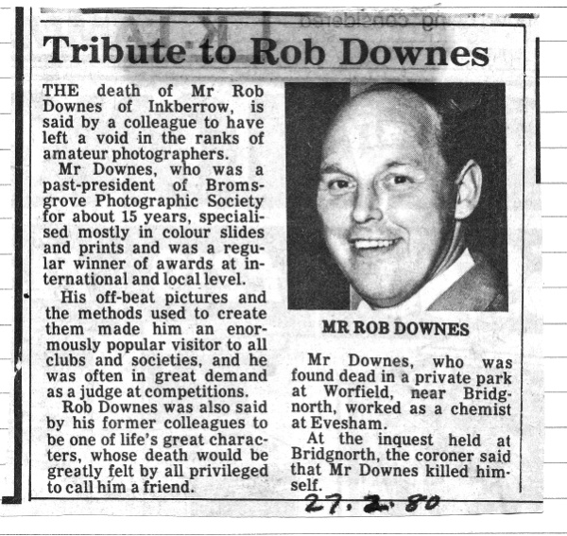
The terrible news that Rob Downes had died on 27th February came as a great shock to us all. The Society will survive but will never be the same again.

April 8th Colin Garratt, the “Steam” photographer, showed us - at great expense – his adventures in Latin America. He does have the gift of the flowery word.
April 15th The Society decided to appoint P. Hadley as its new President to succeed Rob. P.H. said he would reluctantly accept the honour but he could only be second best.
May 13th The day of the “Annual” and the judge, Roger Parry failed to turn up. The Hon Sec, Cliff Gamage, volunteered to do the honours. He gave the Founders Cup to the newly elected President. Was it favouritism? We may never know. Rob Freeman took the Harrison Trophy. Other winners were:- Roy Fisher, G. Hubbard, Madge Williams, Nev Roberts, Ron King, Mick Bonham, John Davidson, Arthur Butler and Trevor Dank. P. Hadley received the Rob Downes Memorial Cup for services to the society.
June 2nd A very impromptu meeting held at the Boat and Railway where the Canal Show was put on and the Society had an invitation (through Bill Chambers). Much liquor was consumed and we attracted a very important new member, Roy Porter, due to our antics.
In general the 80 Summer Programme proved a great success – if only to the local hostelries. We always seemed to end up in a pub! It always rained!
On 15th July Rob Freeman brought two of his Models and very pretty they were. Many rolls of film passed through overheated shutters that night.

1980/81
The usual happy start to the season with a Bring & Buy. The new Auctioneer managed to grind over £60 out of the members, after all costs (booze and grub).
Sunday 6th September We hosted the M.C.P.F. quarterly meeting at Avoncroft – helps get us on the map.
September 16th Len Hedges showed us some old and new photos of Brum. Some going back over 100 years.
October 7th First monthly competition. Mr. Brown the judge with the troublesome cough who always gets it wrong!
October 14th Held the first Photographer of the Year judged by non-photographer of the Arts Society. A successful idea to give the extra reward to all 1.2.3s of previous years monthly’s. Rob Freeman (Print) John Davidson (Slide) took the medals.
October 28th Beer and Skittles at the Bell on A38 near Worcester. Good food, good beer, terrible skittles.
A serious state of affairs arose around the end of 1980 and the start of 81. The Grasshopper ran out of beer due to some industrial conflict. Bad effect on morale!
February 10th The society put on a show at the Baths. Besides our own staff, Mike Wilkes put on an amazing show of his feathered friends. The public were amazed.
February 24th We somewhat foolishly entered into an A/V contest against Hagley and Redditch. We were properly stuffed.
March 3rd and January 24th. The 3rd Monthly Competition showed the emergence of a new and budding star. Peter Young won the Beginners Mono. John Lacey ran him a close 2nd and 3rd. They are our tip for the future of the Society.
In the 5th, another new name came to the fore, Les Watkins won the Beginners Colour Slides and Messrs Young and Lacey fought out the Mono.
Success at Sutton again!
The Society scooped the pool at the M.C.P.F. Annual “do” at Sutton Coldfield, winning the Rosebowl for the Society entry, the Shield for overall quality and the individual award for Merit. The latter was won by Mick Bonham with a superb tranny “A Lonely Cedar”. This title was wrongly reported in the Messenger as a lovely Seeder. The mind boggles.
Marsh 31st 6th Monthly. Due to the Hon Pres handing Roger Noone a large bribe, he won the Slides. John Davidson should have won – but he was broke!
May 12th Ron Smith judged the Annual with consideration and expertise. The winners were
Founders Cup Rob Freeman
Harrison Trophy John Davidson
Rose Bowl Beginners Mono Peter Young
Beginners Slides Mick Bonham
Neville Roberts Natural History Arthur Butler
Dave Morgan and Martin Lewis prevented a clean sweep of awards by the above.
Bill Chambers received the memorial Cup for services to the Society.
End

