BROMSGROVE PHOTOGRAPHIC SOCIETY

AGM MEETING HELD AT
ON TUESDAY 11TH MAY 2021 via Zoom

Meeting commenced at 8.00 pm
Minutes taken by Ele rea , Votes by show of hands and if contentious a full count to be taken
 | PRESENT | 43 members in attendance to include -  Committee-David Jellie – Chair  LA Linda Allen  RC Richard Chapman  JD John Davidson BG Barry Green  JH Jan Harris TH Tony Hawksbee  ER Ele Rea NT Nigel Taylor  AGJ Anne Galbraith-Jellie CC Colin Close  JW Jenny Webster MN Mike Norton  SBS Sheila Ballantyne- Smith  Absent-  JL June Longmuir  JC Janet Cox
 | APOLOGIES | Peter Young , Jill Young, Rebecca Boardman
 | MINUTES OF PREVIOUS MEETING | Minutes of the last year’s AGM , having already circulated, were approved. | Proposed (P) Sheila B-S Seconded (2nd) Ruth Seadon
 | MATTERS ARISING | Ruth asked about the new ways at critiquing Novice members work mentioned last meeting – This will be looked at when face to face is possible , members were reminded that the critique group is open to all , and has been actively encouraged over the year .  Minutes signed off with a majority show of hands | Minutes signed off with a majority show of hands
 | CHAIR’S REPORT  DAVID JELLIE | It has been a year unlike any other. At this point last year we harboured many doubts concerning how Bromsgrove PS could function under regulations and restrictions - the like of which had never been faced by recent generations. We lost one of our senior members - Ken Bryan - to illness. We know of several others who have suffered significant illness or personal challenges at a time when it has been difficult to offer moral support or help. Ours thoughts are with everyone who has suffered in any way over the past 12 months.  Could we find judges and speakers who would be prepared to present remotely. Nowadays we are all experts at Zoom, yet only 15 months ago probably most of use had never heard of it. At that time there were very few speakers and even fewer judges who were willing or able to present on Zoom. We doubted whether we could put a quality programme together for the year. After dipping a toe in the water with presenters for the Sumer programme, we realised that this could work  We didn’t even know how many members would rejoin with no physical meetings. Would enough people accept an online only programme.  Because of this we couldn’t predict our income from membership fees. In some of the darkest moments I doubted that we would reach 50 members. Could we afford speakers of the calibre that we have grown used to - a potentially vicious circle.  Some local clubs and societies took the option of offering little or no programme for their members. We wish them well in the future, but question how strongly they will come through this. Your committee took the decision to face these challenges head-on.  By remaining flexible wherever possible we created an organic programme of presentations and competitions. We have maintained a strong presence on social media and with our display on the High Street, which has helped attract new members. Our member numbers started high and have continued to grow over the year. As a result our finances have remained strong. Furthermore, our judges and presenters have not been hampered by geographical constraints, leading to new faces, new ideas and a wide range of genres. Some of our most entertaining presentations have come from much closer to home, with special thanks to Michael McIlvaney, Jenny Webster, Andy Kent and Tony Gervis.  I want to give my personal thanks to the whole committee for making this all possible. It has been an enormous team effort that has paid dividends  There is no doubt that we have all missed the social aspect of our weekly meetings. Zoom presentations are very limiting for interaction as only one person can talk at a time. As yet, we are uncertain as to whether we can return to full physical meetings in Sept. We are currently looking at how we can use technology to our advantage in the future. There are technological challenges to overcome - not least of all, there is no WIFI available at Avoncroft. We can promise you that we will carry on being flexible to a changing situation and the wishes of our members. Our recent survey will help us make the best decisions for the year ahead.  Last year we took the decision not to produce a printed handbook- this has enabled us to change meetings as circumstances dictated. After debate in committee we have taken the majority decision not to commit ourselves to a full printed handbook for the year ahead - there are so many unknowns. Circumstances permitting, we plan to hold our publicity event on the High Street in August. We will produce promotional leaflets for the public and these will also include a provisional programme for the year ahead. These will also be available for members who prefer to have a printed programme. Other information - such as competition rules, award winners, committee contact details, etc can be found on our website - and printed out should anyone wish.  My major regret for the past 12 months is that we have been unable to offer a comprehensive programme of support to our newer and less experienced members. Rebekah Nash has done an excellent job with presenting the Roger Lewis Foundation Course during our early sessions - and will continue to do so. We will also be establishing a strong and varied programme on many topics in our early sessions - both on the practical and theoretical levels. Above all, we need your feedback on what you would like us to cover. If we can help, we will help.  Growth in members has brought in many new members, showing strong enthusiasm for their hobby and Bromsgrove Photographic Society. I look forward meeting you all in person as soon as possible.  Your society is all about you. Thank you all for enthusiasm, support and good humour over last 12 months. I know you will carry us forward to a strong future. | P- NICK HIND  S-DAVID WARD  ACCEPTED BY A MAJORITY
 | TREASURER’S REPORT  LINDA ALLEN | Introduction  Well - this has been a strange year – unlike any we have experienced before. I would like to record my thanks to my committee colleagues who have done a brilliant job keeping the Society going throughout lockdown; not every club has achieved this. Not only this, I feel that BPS has gone from strength to strength.  As a consequence, this lockdown year has resulted in huge changes to our income and expenditure as you will see from the attached End of Year Accounts. As far as possible I have tried to maintain the usual format for ease of comparison with last year. Inevitably, there are one or two minor changes in headings.  I will be happy to answer any questions at the end of my report.  A quick overview of this year’s accounts reads:  Number of members 71  Total income £5135.50  Total expenditure £5256.66  Operating deficit £ 121.16  Income  Income from membership amounted to £3130.50; the additional moneys being a bequest from Roger Lewis’s estate of £2000 and one member overpaying £5. Due to not physically meeting on our Tuesday nights, we have not been able to raise other revenue from our usual streams such as refreshments, raffles, New Year party etc.  Expenditure  £5256.66 - This does seem a large amount - but as you will have seen, the major item was the transfer of the £2000 to our savings account. Other major purchases have been our new display boards (£569.22) and £700 for sundry purchases; £640 of which was for work carried out to enhance our equipment storage facilities at Avoncroft. As we haven’t been meeting in our usual way, our expenditure on items such as premises and models has been nil this year.  Having transferred the £2000 into the saving account, our current account is still in good shape and stood at £5789.02 on 31st March 2021. Looking at nett income and expenditure, you will see we have incurred an operating deficit of £121.16. Continuing under difficult circumstances, I think this shortfall is not entirely surprising – and we have manged to maintain a lively and interesting programme throughout the year.  Last year it was not possible for Mike Norton to fully examine the accounts. However, this year he has been to do so and is satisfied that they are all in order. Mike will send an email confirming this to all members.  In the past I have usually looked at doing a Value for Money comparing expenditure to membership fee. However, as it has been such an upside down year, I don’t feel that it will have the any relevance this year.  I am happy to answer any questions regarding the accounts before moving on to my proposal for an amendment to the criterion of Concessions in readiness for next season’s application form.  Proposal for change of wording defining concessions:  From: Concessions (Retired/Unemployed/Student)  To: Concessions (65+/Unemployed/Student)  Proposed by: Linda Allen  Seconded by: Sheila Ballantyne-Smith  This year there has been some confusion as to interpretation of “retired”. For Example; does that mean retired from your main career and now working part-time? How many hours constitutes part-time with some members working one or two days a week?  To clarify matters, the committee have agreed that a change of wording would be helpful and avoid confusion in the future. Therefore, I have proposed the above change and hope that members will support the amendment.  There is now an opportunity to discuss the proposal before asking members to vote on whether or not to adopt the new criterion.  My thanks go to all continuing to supporting the club. Let’s hope next year sees us able to return to Avoncroft.  There followed a discussion amongst the members regardingprice increase , no concession , larger concession . No alternate proposal came forward so original one was voted on and passed with a majority show of hands .  Anne Galbraithe -Jellie proposed a donation to Avoncroft in light of the vandalism in the past week , discusiion as to the amount vote was held on £250 donation . Passed with a majority vote . | P-TONY GERVIS  S- NICK VEALE  ACCCEPTED BY MAJORITY  P Ann Galbraithe Jellie S  Ele rea
 | PROGRAMME SECRETARY’S REPORT  JAN HARRIS | Introduction  This past year has been busier for me due to the need to rearrange and organise more speakers who were happy to deliver their talks by Zoom. However, I have received very welcome and uplifting encouragement from the members and the committee for which I am very grateful. I have also had support from members who were happy to volunteer to deliver a presentation.  Presentations  Accessing presentations remotely gave me opportunity to book speakers who did not need to be local or to pay expensive travelling fees.  A reminder of our speakers and genres  Claire Carter – Landscape  Ian Preece – New Zealand Travel/Landscape  Michael McIlvaney – Street  Alan Walker – Travel/Nature  Jane Lazenby – Creative  Adrian Wheele – War/Travel  Damien Demolder – Street  David Keep – Sport/Underwater  Tal Chohan – Nature  Andy Kent – Mixture  Tony Worobiec – Sea Scapes  Phil Savoie - Nature  Tony Gervis - Mixture  Julian Elliot – Travel  Cherry Larcombe - Flower  Member Survey  Thank you so much to all who took the time to complete the member survey which gave the committee a clearer idea about members’ preferences for accessing club events going forward.  The vast majority of you want to get back to face to face meetings with no one saying they wouldn’t attend on a Tuesday evening. However, there were also a number of you who would be very happy to have a mixture of face to face and virtual presentations. I am currently booking face to face speakers and accessing some virtual presentations which will be screened at Avoncroft. Those who want to watch from home will be able to also access the link. Our first presentation for next season (14th September) will be Hunter Kennedy who is based in Scotland so this will give us a trial run.  The survey asked for your where you feel your photography expertise lies. Many of you said you feel you are somewhere in between novice and open. The committee are considering how we might accommodate those preferences going forward.  There was also a catch-all question I asked at the end for general comments. This gave all members a chance to have their say anonymously which I feel is valuable if we are to access all opinions. It may be that an occasional survey is circulated to give members a chance to have their say, however please remember that you can talk to our membership liaison officer, Ele Rea or any member of the committee at any time.  There were some valuable suggestions for improvements which the committee have taken on board and there were also many, many very positive comments and grateful thanks to the committee for the job they have done this past year.  A big thank you to all the members and committee who make this a supportive and friendly club and one I am very proud to be a part of. | P-John Davidson  S-Barry Green  Accepted by majority
 | COMPETITION SECRETARY’S REPORT  NIGEL TAYLOR (given a little later in the evening ) | This last season has presented all photographic societies with a number of challenges but overall I am very happy with the way our competitions have panned out.  All competitions have had to be run through Zoom. Naturally, and sadly, that does remove the important element of social interaction, but the actual competitions have gone ahead as normal.  Several of our local judges felt unable to use Zoom, and also some were unwilling to handle all our prints. I fully understood that, and it was an opportunity to look outside the MCPF area for some new faces. Also, I approached some of the newer “B” Panel judges locally.  Of course, Zoom encourages pre-judging, which personally I feel generally produces a better result. Receiving the images in advance, the judges have more time to look in detail at the technical aspects of the photography. I do fully acknowledge that personal preferences will always play a part in judging, but both in competition, and in the learning aspects of these contests, I do feel that technical excellence in the skills of operating a camera, and getting the absolute best results from your equipment, should be a precursor to receiving an award. I do feel that this has been better this season with the prejudging, although I do not pretend that it is ever perfect.  I thank all the members who have taken part and supported me throughout the year. I know it has not been easy, and those who have followed government guidelines will have had their opportunities to take photographs severely curtailed. I know that many find that holidays away provide their best time for photography and such pleasures have been much reduced throughout the pandemic.  We still have the final monthly print competition next week and the Awards Night in a fortnight. As last year, Zoom will not facilitate the actual handing over of trophies and certificates, but I really hope we can do that in September.  I have not yet considered changes to the competition rules for next season, but nothing major springs to mind.  Finally, I shall be putting my name forward tonight to carry on for a further year as Competition Secretary. However, if appointed, this will be my final year. I have served on committee for over 30 of my 35 years in BPS. I do now have other interests to pursue and so I shall definitely finish at the end of the 2021/22 season. We shall therefore need to find a replacement later this year, giving me time to work with him/her to explain the routine and software involved before I step back. | P- Steve Williams  S-Sheila Ballantyne-Smith  Majority Acceptance
 | WEBMASTER’S REPORT  TONY HAWKSBEE | In the Winter Season of 2020/21 there were a few changes to deal with Covid-19 communications but other than that it was a straightforward year.  As I stated last year, with the speed at which technology advances, my web site knowledge is becoming outdated. However, I think that I’m still coping with the demands and needs of the Society in this area. If there is a member who could possibly shadow me with a view to taking over the role in the future, I would be pleased to hear from you. Knowledge of HTML and Wordpress would be necessary. In the meantime I will continue to the best of my ability.  The website  Wordpress continues to provide a workable free of charge website program for the Society. Our website host, One.com increased their charges but not to the extent that I would recommend the upheaval of moving. They are pretty good. I still have bad memories from when we had to move from the American host “Just Hosts” a few years ago. The laws and regulations over there were causing payment issues for us.  I welcome any suggestions for improvement of the site but bear in mind it is free software and isn’t always capable of many of the things sophisticated paid for software is capable of.  Website Statistics  Due to the problems of compliance with GDPR, I am still unable to provide meaningful statistical information about the visitors to the site. I may re-visit this again this year.  General website news  To a certain extent Covid-19 has affected input from the Specialist Groups leaders. The stand out exception to this is Jenny Webster’s Nature Tips blog which she keeps up regularly each month. I would welcome input for the website from anyone.  The Data Protection Act 2018 incorporating the EU General Data Protection Regulations (GDPR)  This seems to have settled down now. However, again it would be good if there was a member who, through their work knowledge on the subject, could keep me up to date with any necessary updating that might be needed.  Zoom and YouTube  My thanks go to Richard Chapman who has been a wizard with these new facilities. He has a slick way of adding the recordings to the website. They are stored here  https://www.bromsgroveps.com/programme-2/members-only-zoom-links/  If there is a member who has forgotten the Member’s Only page password, please email me and I will send it to you.  Richard also adds the PhotoEntry images and winners details to the site almost immediately after the competitions. Amazing.  My thanks also go to the Committee for their continuing support.  Tony said we are still hacked regularly and the password is changed regularly | P-Anne Galbraithe Jellie  S- Richard Chapman  Majority accepted
 | PUBLICITY OFFICER’S REPORT  ANNE GALBRAITHE-JELLIE | 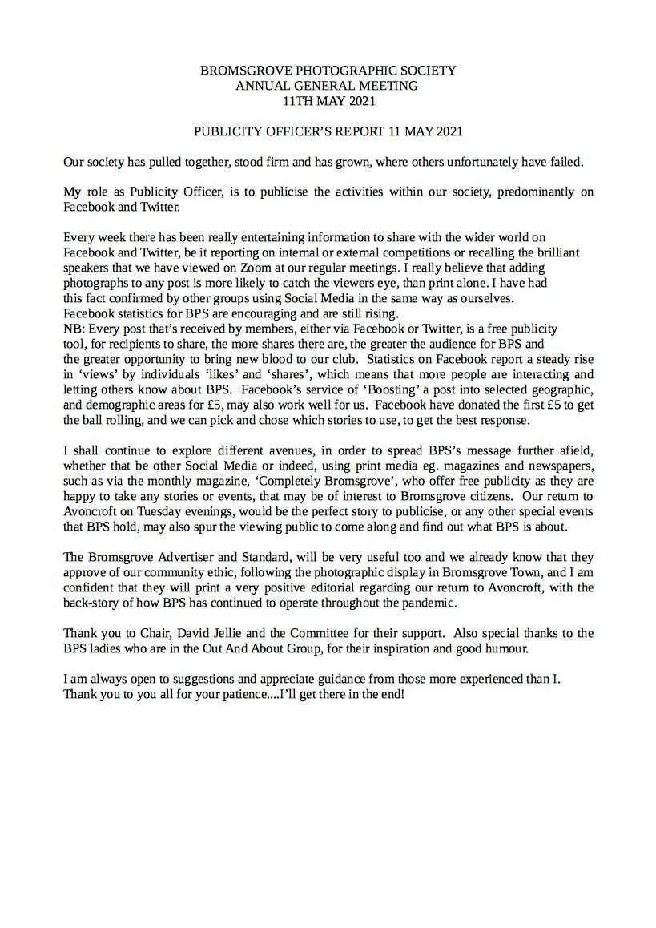  David Ward raised his concerns regarding the pictures that had fallen on the High St display .Since the new boards have been placed in the venue there is only one errant picture . So no longer a major issue . We have limited access to this free advertising space . The boards will be utilised for the High Street presentation and the display re assessed after . | P- Colin Close  S- Barry Green  Majority accepted
 | SOCIAL SECRETARY’S REPORT | NO REPORT
 | INTER CLUB COORDINATOR’S REPORT  JENNY WEBSTER | This year has been very enjoyable and fulfilling, a goal to involve as many members, as possible to represent the club from novice to Open, was achieved.  At the same time trying to score a high standard score, so to do well and win some trophys.however alot of that is luck and the judges.  I Feel the job of inter club sec, is to keep the members feeling involved, and encourage them to all work towards the knowledge that as they improve, in their photography they will be rewarded by being chosen to represent their club.  I Have been very grateful to Colin Close during the whole year, for his support..and i could not have done the selecting without the support of Sue Vernon Richard Chapman Colin Close helping me….it has made inter club sec job a pleasure.  My next year will be spent trying to win more inters rather than just 1 but always first and foremost keeping the selection to include a wide selection of members….  the calendar, distinction group ,summer programme ,and nature blog are all in hand and up to date. | P-Sheila Ballantyne Smith  S-Jan Harris  Majority accepted
 | MEMBERSHIP LIAISON COORDINATOR’S REPORT  ELE REA | A challenging year , but we are still here and still going strong .  The feedback from members has been very positive .  We are keen to get back to face to face so we can give more support to the Novice members and encourage the influx of new members .  With the strength in the membership we are looking at new ways to encourage and support our new and Novice members .  Any ideas , please approach me or the other members of the Committee , we are always open to suggestions and help .  Hopefully the full summer programme will re unite us and take us in to the next season raring to go with a bank of fresh images . | P- Richard Chapman  S-Linda Allen  Majority accepted
 | EXTERNAL COMPETITION COORDINATOR’S REPORT  COLIN CLOSE | It has been a difficult year due to Covid pandemic and lock down restrictions. However, due to the ease of entering digital projected exhibitions using their software and paying on line it has been possible for several members to continue or start having success.  What has been missing is entering prints and attending Midland area exhibitions to view accepted prints and view all digital acceptances.. This is one of the best ways to improve your photography ( apart from taking a lot of meaningful pictures).  I have circulated details of BPE (British Photographic Exhibitions) via bpsmembers Google Group and also International Exhibitions (several of which are UK based). These exhibitions can be entered by anyone – even non club photographers! Many entrants target exhibitions in order to accumulate points towards achieving awards eg BPE 1-5 Crowns, AFIAP PSA Awards.  Google BPE/FIAP/PSA for more information.  I also encourage members to go for PAGB Awards (another one to Google). Their first award is CPAGB and expected standard for entering is “good club photography”. In recent years we have had several successful members for CPAGB. Part of the process is having work good enough to gain acceptance in exhibitions. More importantly attendance at PAGB workshops is to be encouraged and these should start again soon. Smethwick PS often hosts the event.  All members should register to receive MCPF digital Newsletter which informs about midland exhibitions/workshops/ etc.  Sean Bullock asked if it was correct that you couldn’t enter external competitions for 2 years after joining , it was explained this only applies to the PAGB award . | P- TONY FRIEL  S- JOHN DAVIDSON  MAJORITY ACCEPTANCE
 | PROPOSALS | One proposal dealt with earlier , no other written proposals were received .
 | ELECTION OF OFFICERS | No one had come forward for election to Committee .  The current Committee members confirmed at a recent committee meeting they were all happy to continue in their offices for the next year .  David Jellie will continue as Chairman to give Richard Chapman time before stepping in to the role .  David Ward asked about Committee roles – it was confirmed all Committee positions are filled with 4 General Committee members | Majority acceptance of Committee
 | ANY OTHER BUSINESS | Mike was asked to talk about the summer programme-  First month to be -A Zoom meeting , Visit to Droitwich, visit to Bromsgrove High St ,and a possible evening visit to Avoncroft .Mike will get the programme out to all and on the website very soon . The aim is to have a ‘go to’ mentor on each trip to help new and novice members .  Colin Close suggested using the walled garden with small groups of members, with a member as a model, to discuss and practice portrait photography.  Pauline Grainger requested we show consideration to mobility issues when organising trips with club . Jenny pointed out that she always includes all this information in her arrangements.  David reassured that as a club moving forwards we will strive to assist members in enjoying as many outings as possible .  Ruth Seadon thanked the committee for all their hard work and how well they had overcome all the challenges of the past year .  David Jellie thanked the Committee and the membership .
 | DATE OF NEXT AGM | The next meeting will be notified next year
 |  | The Meeting closed at 10-05 pm

